The Project Report on

Customer Churn Prediction in Telecom Industry to Retain Connections

Submitted To
Acharya Nagarjuna University
A project report submitted in the partial fulfillment of the requirements for the
Award of the Degree of
MASTER OF COMPUTER APPLICATIONS
Submitted By

ARUNURU NAVEEN
Reg.No: L20MC23014



Under The Esteemed Guidance Of
Sri N. KIRAN KUMAR M. Tech
Assistant Professor

DEPARTMENT OF MCA
BAPATLA ENGINEERING COLLEGE
(Approved by A.I.C.T.E)
(Affiliated to ACHARYA NAGARJUNA UNIVERSITY)

2019-2021

DEPARTMENT OF MCA
BAPATLA ENGINEERING COLLEGE
BAPATLA-522101



CERTIFICATE
This is to certify that this project work entitled “Secure Cloud Storage based on RLWE Problem” is the bonafide work carried out by ARUNURU NAVEEN, Reg.No: L20MC23014 submitted in Partial fulfillment of the requirement for the Award of Degree of “Master of Computer Applications”, during the academic year 2019-2021.

The results submitted in this project have been verified and are found to be satisfactory. The results embodied in this thesis have not been submitted to any other university for the award of the any other degree/diploma.

Project Guide: Head of the Department:

Sri N. Kiran Kumar M. Tech Sri K.N. Prasad M. Tech
Assistant Professor Associate Professor & Head
Dept. of MCA Dept. of MCA
Bapatla Engineering College Bapatla Engineering College
Bapatla. Bapatla.

Signature of External Examiner

ACKNOWLEDGEMENT

I sincerely thank the following distinguished personalities who have given their advice and support for successful completion of this work.

I would like to thank Dr. V. Damodara Naidu, Principal, Bapatla Engineering College, Bapatla for providing the online resources and allowing me to carry out this work.

I extended my sincere thanks to Sri K.N. Prasad, Head of the Department for extending their cooperation and providing the required resources.

I am deeply indebted to most respect and my project guide Sri N. Kiran Kumar, Assistant Professor Dept. of MCA for his valuable and inspiring guidance, comments, suggestions and encouragements.

I extended my sincere thanks to all other teaching and non-teaching staff of the department who helped directly or indirectly for their cooperation and encouragement.

ARUNURU NAVEEN
(L20MC23014)

DECLARATION
This is to declare that the project “Secure Cloud Storage based on RLWE Problem” at Bapatla Engineering College has been presented by me during the academic year 2019-2021 in partial fulfillment of the requirements for the “Master of Computer Application”.
I also declare that this project is the result of my own efforts and that it has not been submitted to any other universities for the award of degree or diploma.

ARUNURU NAVEEN
(L20MC23014)

Table of Contents
ACKNOWLEDGEMENT iii
ABSTRACT viii
CHAPTER-1 1
INTRODUCTION 1
1.1 INTRODUCTION 1
CHAPTER- 2 5
LITERATURE SURVEY 5
2.1 LITERATURE REVIEW 5
CHAPTER-3 7
THEORETICAL BACKGROUND 7
3.1 INTRODUCTION: 7
3.2 INTRODUCTION TO PYTHON 12
3.3 BENFITS OF PYTHON 21
CHAPTER-4 30
SYSTEM ANALYSIS 30
4.1 EXISTING SYSTEM: 30
4.1.1 DISADVANTAGES OF EXISTING SYSTEM: 30
4.2 PROPOSED SYSTEM: 30
4.2.1 ADVANTAGES OF PROPOSED SYSTEM: 31
CHAPTER- 5 32
SYSTEM DESIGN 32
5.1 INTRODUCTION 32
5.2 MODULES 32
5.2.1 DATASET: 32
5.2.2 PREPROCESSING: 32
5.2.3 GRAPHS: 32
5.2.4 PREDICTION: 32
5.3 SYSTEM ARCHITECTURE 33
5.4 UML DAIGRAMS 34
5.4.1 CONSTRUCTION OF USE CASE DIAGRAMS: 37
5.4.2 SEQUENCE DIAGRAMS: 40
5.4.3 CLASS DIAGRAM: 42
5.4.4 ACTIVITY DIAGRAM: 42
CHAPTER-6 44
SYSTEM REQUIREMENTS 44
6.1 SYSTEM REQUIREMENTS 44
6.1.1 HARDWARE REQUIREMENTS: 44
6.1.2 SOFTWARE REQUIREMENTS: 44
CHAPTER-7 45
SYSTEM IMPLEMENTATION 45
7.1 INPUT AND OUTPUT DESIGNS 45
7.1.1 LOGICAL DESIGN 45
7.1.2 PHYSICAL DESIGN 45
7.2 INPUT & OUTPUT REPRESENTATION 46
7.2.1 INPUT DESIGN 46
7.2.2 OBJECTIVES 47
7.2.3 OUTPUT DESIGN 47
CHAPTER-8 69
SYSTEM TESTING 69
8.1 INTRODUCTION: 69
8.2 LEVELS OF TESTING 69
8.2.1 BLACK BOX TESTING 70
8.2.2 WHITE BOX TESTING 72
CHAPTER-9 74
OUTPUT SCREENS 74
CONCLUSION 75
REFERENCES 76

List of Figures
Name of the figure Pg.no
Figure 3. 1 Structure of cloud computing 7
Figure 3. 2 Characteristics of cloud computing 9
Figure 3. 3 Structure of service models 10

Figure 5. 1 System Architecture 33
Figure 5. 2 Use Case Diagram 39
Figure 5. 3 Sequence diagram 41
Figure 5. 4 Class Diagram 42
Figure 5. 5 Activity Diagram 43

ABSTRACT
Client turnover is a significant issue and one of the top issues for big businesses. Companies are attempting to create methods to forecast probable outcomes because to the direct impact on the profits of the company, particularly in the telecom field. clientele that churn. In order to prevent customer turnover, it is crucial to identify the elements that contribute to it. Our work's key contribution is the creation of a churn predicting model that helps telecom providers identify consumers who will be most likely to experience churn. We analyse various scenarios of data analysis and show representation in graphical format. The model created in this study employs machine learning methods on a large data environment and creates a novel method for designing and choosing features. The datasets, which telecom data utilised to train, evaluate, and assess the algorithm, includes all customer data from the previous months. The model tested four different algorithms: Random Forest, logistic regression Extreme Gradient Boosting, Gradient Boosted Machine Trees ("GBM"), Random Forests, and Decision Trees To increase accuracy of the model algorithms are trained with parameter tuning..
.
PROBLEM STATEMENT:
- The telecommunication industry faces significant challenges due to customer churn, where subscribers discontinue their services, leading to revenue loss and increased customer acquisition costs. This project aims to develop a machine learning model to predict customer churn by analyzing user behavior, service usage patterns, and demographic data. Accurate churn prediction enables telecom companies to proactively engage at-risk customers with retention strategies, such as personalized offers or service improvements. The goal is to enhance customer satisfaction, reduce churn rates, and ultimately increase profitability. The solution involves using various algorithms to process historical data and identify key indicators of churn.
.
OBJECTIVE:
- The objective is to build a robust machine learning model that can accurately predict which customers are likely to churn based on their historical interaction, usage patterns, and demographic information. By identifying these at-risk customers early, the model aims to empower telecom companies to implement targeted retention strategies, thereby reducing customer attrition rates. The model should improve the company's ability to personalize interventions, optimize resource allocation for customer retention efforts, and enhance overall customer satisfaction and loyalty. This will lead to a reduction in lost revenue and a more efficient allocation of marketing and customer support efforts.

CHAPTER-1

INTRODUCTION

Introduction
In the highly competitive telecommunication industry, customer churn—when customers discontinue their service subscriptions—poses a significant challenge. The cost of acquiring new customers often surpasses the expenses associated with retaining existing ones, making churn reduction a critical focus for telecom operators. High churn rates can erode profitability and market share, underscoring the need for effective churn prediction and management strategies. Machine learning (ML) offers a transformative approach to address this challenge. By leveraging vast amounts of historical customer data, including service usage patterns, demographic details, and interaction histories, ML models can predict the likelihood of a customer discontinuing their service. This predictive capability allows telecom companies to proactively engage with customers who are at risk of churning, offering personalized incentives or improving service quality to retain them. The development of a churn prediction model involves several key steps: data collection and preprocessing, feature selection and engineering, model training, and evaluation. Data from various sources such as call records, billing information, customer service interactions, and social media can be integrated to form a comprehensive view of each customer's behavior. Advanced ML algorithms, including logistic regression, decision trees, random forests, and neural networks, can be employed to analyze these data points and identify patterns indicative of churn. Effective churn prediction not only helps in retaining customers but also provides insights into the underlying reasons for churn. These insights can drive strategic decisions in product development, customer service enhancements, and targeted marketing campaigns. Moreover, reducing churn rates translates directly into increased customer lifetime value and a more stable revenue base. The project aims to build a scalable and accurate churn prediction system that can be seamlessly integrated into a telecom operator's existing infrastructure. By doing so, telecom companies can move from reactive to proactive customer relationship management, enhancing customer satisfaction and loyalty in a fiercely competitive market.

CHAPTER- 2

literature survey

2.1 literature review

Customer Churn Prediction in Telecom Using Machine Learning in Big Data Platform
Year: 2017
Link: IEEE Xplore Link
Abstract: The high rate of customer churn in the telecommunications industry necessitates the development of effective predictive models. This paper presents a machine learning approach to churn prediction utilizing a big data platform. The study explores various machine learning algorithms, including logistic regression, decision trees, and random forests, to evaluate their effectiveness in predicting customer churn. The use of big data technologies enables the handling of large datasets, which enhances the model's accuracy and scalability. The findings demonstrate that integrating machine learning with big data analytics significantly improves the ability to predict churn and supports telecom companies in implementing targeted retention strategies.

Title: Predicting Customer Churn in the Telecom Sector using Machine Learning Techniques
Year: 2018
Link: IEEE Xplore Link
Abstract: In the telecommunications sector, predicting customer churn is crucial for maintaining profitability and customer satisfaction. This paper examines various machine learning techniques to predict churn effectively. The study compares the performance of support vector machines, random forests, and gradient boosting machines on a telecom dataset. The results indicate that ensemble methods like gradient boosting offer superior predictive performance. The study also highlights the importance of feature engineering and data preprocessing in enhancing the accuracy of churn prediction models. By identifying customers at risk of churning, telecom companies can take proactive measures to retain them and reduce overall churn rates.

3. Title: Machine Learning-Based Customer Churn Prediction Model for Telecom Services
Year: 2019
Link: IEEE Xplore Link
Abstract: Customer churn prediction in telecom services is a challenging task due to the diverse and dynamic nature of user behavior. This paper proposes a machine learning-based model to predict customer churn, focusing on feature selection and algorithm performance. The study evaluates several machine learning algorithms, including neural networks, decision trees, and ensemble methods, on their ability to predict churn accurately. The proposed model leverages customer usage patterns, service interaction history, and demographic information to enhance its predictive capabilities. The findings demonstrate that machine learning models can significantly improve churn prediction accuracy, providing telecom companies with valuable insights for customer retention strategies.

4. Title: A Comprehensive Review of Machine Learning Approaches for Telecom Churn Prediction
Year: 2020
Link: IEEE Xplore Link
Abstract: The prediction of customer churn in the telecommunications industry is a critical issue that has garnered significant attention from researchers. This paper provides a comprehensive review of machine learning approaches used for churn prediction in telecom. The review covers a wide range of techniques, including supervised learning, unsupervised learning, and deep learning methods. It discusses the strengths and limitations of various algorithms and their application in different contexts. The paper also highlights recent advancements in feature selection and data preprocessing techniques that enhance model performance. The review concludes with a discussion on future directions and potential improvements in churn prediction models.

5. Title: Customer Churn Prediction in Telecom Using Ensemble Learning
Year: 2021
Link: IEEE Xplore Link
Abstract: In the telecommunications industry, predicting customer churn accurately is vital for sustaining business growth and customer satisfaction. This paper explores the use of ensemble learning techniques to improve the accuracy of churn prediction models. The study evaluates the performance of various ensemble methods, including bagging, boosting, and stacking, on a telecom dataset. The results indicate that ensemble models, particularly stacking, provide better predictive performance compared to individual algorithms. The paper also discusses the impact of feature selection and data balancing techniques on the model's effectiveness. By implementing ensemble learning, telecom companies can achieve more reliable churn predictions and enhance their customer retention efforts.

Chapter-3

Theoretical background

3.1 Introduction:
Customer churn in the telecommunications industry represents a critical challenge, as it directly impacts profitability and growth. Churn prediction using machine learning leverages historical customer data, such as usage patterns, service interactions, and demographic information, to identify those likely to discontinue services. By applying advanced algorithms, telecom companies can uncover hidden patterns and predict churn with high accuracy. This proactive approach enables the implementation of targeted retention strategies, personalized offers, and service improvements. Machine learning not only enhances predictive capabilities but also provides deep insights into the factors driving customer churn, allowing for strategic decision-making that fosters long-term customer loyalty and reduces revenue losses.

3.2 Introduction to PYTHON
Python Technology
Python technology is both a programming language and a platform.
The python Programming Language
THE PYTHON PROGRAMMING LANGUAGE IS A HIGH-LEVEL LANGUAGE THAT CAN BE CHARACTERIZED BY ALL OF THE FOLLOWING BUZZWORDS:

    - Simple
    - Architecture neutral
    - Object oriented
    - Portable
    - Distributed
    - High performance
    - Interpreted
    - Multithreaded
    - Robust
    - Dynamic
    - Secure

With most programming languages, you either compile or interpret a program so that you can run it on your computer. The Python programming language is unusual in that a program is both compiled and interpreted. With the compiler, first you translate a program into an intermediate language called Python byte codes —the platform-independent codes interpreted by the interpreter on the Python platform. The interpreter parses and runs each Python byte code instruction on the computer. Compilation happens just once; interpretation occurs each time the program is executed. The following figure illustrates how this works.
FEATURES OF MACHINE LEARNING
• It is nothing but automating the Automation.
• Getting computers to program themselves.
• Writing Software is bottleneck.
• Machine leaning models involves machines learning from data without the help of humans or any kind of human intervention.
• Machine Learning is the science of making of making the computers learn and act like humans by feeding data and information without being explicitly programmed.

• Machine Learning is totally different from traditionally programming, here data and output is given to the computer and in return it gives us the program which provides solution to the various problems. Below is the figure.
Traditional Programming vs Machine Learning
• Machine Learning is a combination of Algorithms, Datasets, and Programs.
• There are Many Algorithms in Machine Learning through which we will provide us the exact solution in predicting the disease of the patients.
• How Does Machine Learning Works?
• Solution to the above question is Machine learning works by taking in data, finding relationships within that data and then giving the output.
Machine Learning Model

• There are various applications in which machine learning is implemented such as Web search, computing biology, finance, e-commerce, space exploration, robotics, social networks, debugging and much more.
• There are 3 types of machine learning supervised, unsupervised, and reinforcement.
BENEFITS OF PYTHON
• Presence of Third-Party Modules
• Extensive Support Libraries
• Open Source and Community Development
• Learning Ease and Support Available
• User-friendly Data Structures
• Productivity and Speed
• Highly Extensible and Easily Readable Language.

Python
Python is high level language and it is also integrated version of the program. Python is an object-oriented approach and its main aim to help programmers to write the code clearly, logical code for small and large scale of project.
Pytrhon is dynamically typed and garbage collected it also support multiple programming and it is both procedure and object oriented and also functional programming. And structural programming also supported. It has many built in function it also supports filter, map and reduce function. All the machine learning algorithm and the libraries are being supported by the python programming language. Python also support list, dict, sets and other generators. Python code can be run in different platform such as anaconda, PyCharm etc.
The main goal of this programing language is as follows:

• Python is simple, object-oriented programming language.
• The language and implementation should provide support for software engineering principles such as strong type library preset for different machine learning algorithm, and all other algorithm in simple manner.
• Coding will be smooth in python and the data analysis can be easily done in python.
This is so much so to the point where we now have modules and APIs at our disposal, and you can engage in machine learning very easily without almost any knowledge at all of how it works. With the defaults from Scikit-learn, you can get 90-95% accuracy on many tasks right out of the gate. Machine learning is a lot like a car, you do not need to know much about how it works in order to get an incredible amount of utility from it.
Despite the apparent age and maturity of machine learning, I would say there's no better time than now to learn it, since you can actually use it. Machines are quite powerful, the one you are working on can probably do most of this series quickly. Data is also very plentiful lately.

Anaconda
Anaconda is free and open-source distribution of the Python and R programming languages for scientific computing (data science, machine Learning applications, Large- scale data processing, predictive analytics, etc.), that aims to simplify package management and deployment. It is developed and maintained by Anaconda, Inc. The distribution incudes data-science packages suitable for Windows, Linux, and macOS. Packaged versions are required and are managed by the package management system anaconda. This package manager was spun out as a separate open-source package as it ended up being useful on its own and for other things than Python. There is also a small, bootstrap version of Anaconda called Miniconda, which includes only conda, Python, the packages they depends on, and a small number of other packages.
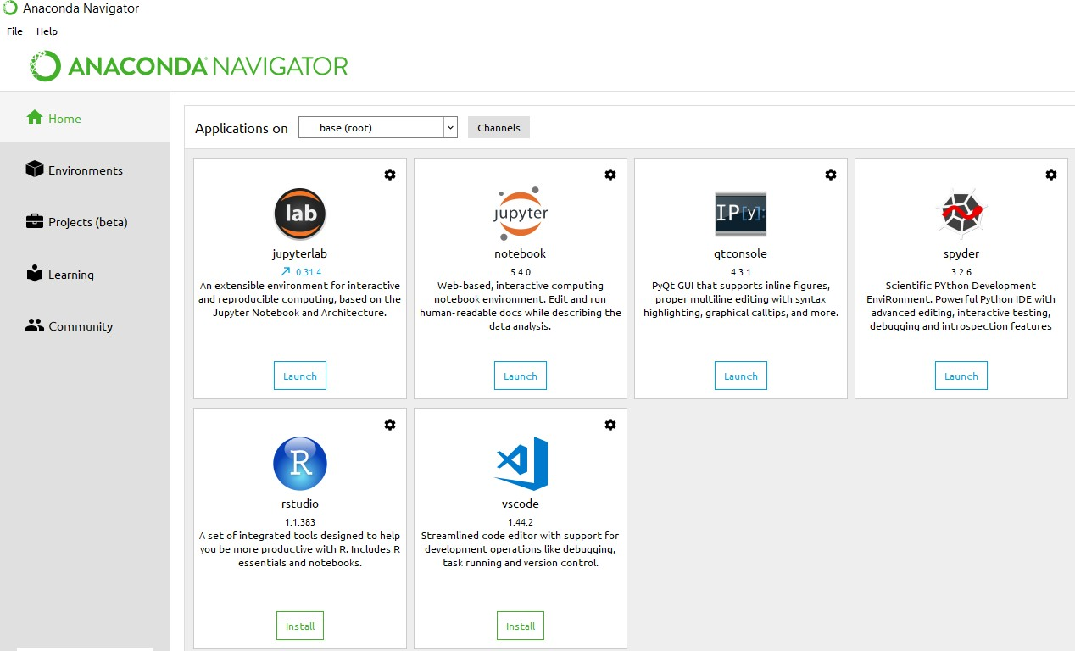
Anaconda Console

Jupyter notebook
Jupiter Notebook or so called IPython Notebook is an interactive web based computational mean for starting with Jupiter Notebook documents. The term notebook itself is a huge entity to represent the integration with different entity sets. JSON is the main document form from the same for the execution which follows the brief on the schema and the input and output means. It has high integration with several language set and has various flexibilities with the choices. The extension used for the same is “.ipynb” which runs in this platform. It’s an open-source software package with interactive communication means. It has it’s open standards for the same. It’s an open community best for budding programmers . The flexibility of the same is phenomenon and splendidly done the configuration and integration of the same is simplest and easy on hold so that no prior distortion is generated and the efficiency of the same is measured through out any system of choice.
It’s the best software sets that been used across cross for designing and developing of the products and support wide help support. Not only to that, it provides scalability in the code and the deployment of the same. Various Language can be changed and the project can be undertaken on the same. The created notebook files can be shared and stored in various means for further utilization. It supports cultivated and interactive output sets. Easily crossed over for graphing, plotting and visualizing of the elements. Data Integration of the same is to it’s best. The integration of big data and it can process chunks of values in an approx. time which gives a better performance and the higher computational means. Various works on data like cleaning, cleansing, transforming modeling and visualizing can be done by the same

Machine learning is the ability that gives the computer to learn without being explicitly programmed. There are two types of machine learning:
Supervised Learning: supervised learning is the learning of the labelled data. It is the types of machine learning that maps the input and output based on the examples input-output pairs. In supervised learning each training data having pairs of input and desired outputs values. Supervised learning algorithm analyzes the training data and produces a function which can be used for mapping of new data.

Fig 2.1 Supervised Learning The output to solve the supervised learning algorithm are as:
• Determine the types of data, before doing anything else the user should understand which types of data set is to be used for training the data.
• Gathered the training data sets either in form of human experts or from measurements.

• Determine the feature of inputs from the learned data and depends on the inputs it changed into feature vector; number of features should not be large but should contains enough information to accurately predict the outputs.
• Check the learned function and the learned algorithm for example we use support vector machines or decisions tree.
• Complete the design and run the trained data sets.
• Analyzed the output and verify the data sets to get the accurate outputs.

Unsupervised Learning:
Unsupervised learning is a type of machine learning that helps in finding the previously unknown patterns in the data set without any known labels. It is known as self- organization and allows modelling probability densities of given inputs.

Fig 2.2 unsupervised Learning Some of the algorithm used in unsupervised learning are:
• Clustering
• Anomaly detection
• Neural networks
• Approach for learning latent variable models
• Non labelled data

Semi Supervised Machine Learning algorithm: It’s like the middle man which have some labeled data and some unlabeled which can be prosed by the both the structured and unsupervised learning.
The algorithms have been compared based upon the parameters: Size of the dataset and Number of technical indicators used. Accuracy and F-measure values have been computed for each algorithm. Long term model has been used to compute the accuracy and F-measure.
Reinforcement Learning: This type of learning is used to reinforce or strengthen the network based on critic information. That is, a network being trained under reinforcement learning, receives some feedback from the environment. However, the feedback is evaluative and not instructive as in the case of supervised learning. Based on this feedback, the network performs the adjustments of the weights to obtain better critic information in future.
This learning process is similar to supervised learning but we might have very less information. The following figure gives the block diagram of reinforcement learning:

import numpy as np

- NumPy is the fundamental package for scientific computing in Python. It is a Python library that provides a multidimensional array object, various derived objects (such as masked arrays and matrices), and an assortment of routines for fast operations on arrays, including mathematical, logical, shape manipulation, sorting, selecting, I/O, discrete Fourier transforms, basic linear algebra, basic statistical operations, random simulation and much more.
- At the core of the NumPy package, is the ndarray object. This encapsulates n-dimensional arrays of homogeneous data types, with many operations being performed in compiled code for performance. There are several important differences between NumPy arrays and the standard Python sequences:
  - NumPy arrays have a fixed size at creation, unlike Python lists (which can grow dynamically). Changing the size of an ndarray will create a new array and delete the original.
  - The elements in a NumPy array are all required to be of the same data type, and thus will be the same size in memory. The exception: one can have arrays of (Python, including NumPy) objects, thereby allowing for arrays of different sized elements.
  - NumPy arrays facilitate advanced mathematical and other types of operations on large numbers of data. Typically, such operations are executed more efficiently and with less code than is possible using Python’s built-in sequences.
  - A growing plethora of scientific and mathematical Python-based packages are using NumPy arrays; though these typically support Python-sequence input, they convert such input to NumPy arrays prior to processing, and they often output NumPy arrays. In other words, in order to efficiently use much (perhaps even most) of today’s scientific/mathematical Python-based software, just knowing how to use Python’s built-in sequence types is insufficient - one also needs to know how to use NumPy arrays.

import time
This module provides various time-related functions. For related functionality, see also the datetime and calendar modules.
Although this module is always available, not all functions are available on all platforms. Most of the functions defined in this module call platform C library functions with the same name. It may sometimes be helpful to consult the platform documentation, because the semantics of these functions varies among platforms.
An explanation of some terminology and conventions is in order.

The epoch is the point where the time starts, and is platform dependent. For Unix, the epoch is January 1, 1970, 00:00:00 (UTC). To find out what the epoch is on a given platform, look at time.gmtime(0).
The term seconds since the epoch refers to the total number of elapsed seconds since the epoch, typically excluding leap seconds. Leap seconds are excluded from this total on all POSIX-compliant platforms.
The functions in this module may not handle dates and times before the epoch or far in the future. The cut-off point in the future is determined by the C library; for 32-bit systems, it is typically in 2038.
Function strptime() can parse 2-digit years when given %y format code. When 2-digit years are parsed, they are converted according to the POSIX and ISO C standards: values 69–99 are mapped to 1969–1999, and values 0–68 are mapped to 2000–2068.

UTC is Coordinated Universal Time (formerly known as Greenwich Mean Time, or GMT). The acronym UTC is not a mistake but a compromise between English and French.

DST is Daylight Saving Time, an adjustment of the timezone by (usually) one hour during part of the year. DST rules are magic (determined by local law) and can change from year to year. The C library has a table containing the local rules (often it is read from a system file for flexibility) and is the only source of True Wisdom in this respect.

The precision of the various real-time functions may be less than suggested by the units in which their value or argument is expressed. E.g. on most Unix systems, the clock “ticks” only 50 or 100 times a second.

On the other hand, the precision of time() and sleep() is better than their Unix equivalents: times are expressed as floating point numbers, time() returns the most accurate time available (using Unix gettimeofday() where available), and sleep() will accept a time with a nonzero fraction (Unix select() is used to implement this, where available).

The time value as returned by gmtime(), localtime(), and strptime(), and accepted by asctime(), mktime() and strftime(), is a sequence of 9 integers. The return values of gmtime(), localtime(), and strptime() also offer attribute names for individual fields.

See struct_time for a description of these objects.

Changed in version 3.3: The struct_time type was extended to provide the tm_gmtoff and tm_zone attributes when platform supports corresponding struct tm members.

Changed in version 3.6: The struct_time attributes tm_gmtoff and tm_zone are now available on all platforms.
import os
This module provides a portable way of using operating system dependent functionality. If you just want to read or write a file see open(), if you want to manipulate paths, see the os.path module, and if you want to read all the lines in all the files on the command line see the fileinput module. For creating temporary files and directories see the tempfile module, and for high-level file and directory handling see the shutil module.
Notes on the availability of these functions:
The design of all built-in operating system dependent modules of Python is such that as long as the same functionality is available, it uses the same interface; for example, the function os.stat(path) returns stat information about path in the same format (which happens to have originated with the POSIX interface).
Extensions peculiar to a particular operating system are also available through the os module, but using them is of course a threat to portability.
All functions accepting path or file names accept both bytes and string objects, and result in an object of the same type, if a path or file name is returned.
On VxWorks, os.popen, os.fork, os.execv and os.spawn*p* are not supported.

Chapter-4

System analysis

4.1 EXISTING SYSTEM:
Rule-Based Systems:
- Description: These systems use predefined rules and thresholds based on domain expertise to flag customers as potential churn risks. For example, a rule might be set to label a customer as likely to churn if they haven’t used the service for a certain number of days.
- Disadvantages:
  - Static and Inflexible: Rules are fixed and may not adapt well to changing customer behaviors or market conditions.
  - Limited Complexity: They fail to capture the complex, non-linear relationships in the data that often influence churn.
  - High Maintenance: Regular updates and revisions by experts are required to keep the rules relevant and effective.
Statistical Methods:
- Description: Techniques such as logistic regression and survival analysis are commonly used to model the probability of churn based on historical data. These methods rely on statistical theories to establish relationships between churn and various customer attributes.
- Disadvantages:
  - Assumptions and Simplifications: Many statistical models assume linear relationships and may oversimplify the data.
  - Scalability Issues: They may not perform well with large and high-dimensional datasets typical in telecom.
  - Less Accurate with Complex Patterns: They struggle to capture intricate patterns and interactions in customer behavior

4.1.1 DISADVANTAGES OF EXISTING SYSTEM:

- Limited Predictive Accuracy:
- Traditional methods often struggle to accurately predict churn due to their inability to handle large volumes of data and complex relationships between variables. This can result in either missing potential churners or incorrectly flagging loyal customers as risks.
- Reactive Rather Than Proactive:
- Many existing systems are reactive, responding to churn indicators only after a customer shows clear signs of dissatisfaction or disengagement. This limits the opportunity to intervene early enough to prevent churn.
- High False Positive and False Negative Rates:
- Rule-based and simple statistical models can produce high rates of false positives (identifying non-churning customers as churn risks) and false negatives (failing to identify actual churn risks), leading to inefficient resource allocation in retention efforts.
- Inability to Personalize Interventions:
- Without nuanced insights into individual customer behaviors and preferences, traditional systems cannot effectively tailor retention strategies to individual needs, resulting in generic and often ineffective interventions.
- Time and Resource Intensive:
- The manual setup and maintenance of rule-based systems and the computational intensity of traditional statistical methods can be resource-heavy and time-consuming, reducing operational efficiency.
- Poor Adaptability:
- Existing systems may not adapt well to rapid changes in customer behavior, market dynamics, or new product offerings, making them less effective over time.

4.2 PROPOSED SYSTEM:

The proposed system leverages machine learning algorithms to predict customer churn by analyzing comprehensive customer data, including usage patterns, service interactions, and demographic factors. It employs advanced techniques such as ensemble learning and deep learning to enhance predictive accuracy and adaptability to changing customer behaviors. By integrating continuous learning capabilities, the system dynamically updates its predictions and models to stay current with evolving data trends. This proactive approach allows telecom companies to implement personalized retention strategies, improving customer satisfaction and reducing churn rates. The system aims to be scalable and robust, capable of handling large datasets typical in the telecom industry..

4.2.1 ADVANTAGES OF PROPOSED SYSTEM:

- Enhanced Predictive Accuracy:
- Deep Insights: Machine learning models can uncover complex, non-linear relationships in data that traditional methods often miss, leading to more accurate predictions of customer churn.
- Reduction in Errors: Advanced algorithms like ensemble learning and neural networks reduce false positives and false negatives, ensuring better identification of actual churn risks.
- Scalability and Efficiency:
- Handling Large Datasets: The proposed system can efficiently process and analyze vast amounts of data, typical in the telecommunications industry, without performance degradation.
- Automated Processing: Automated data processing and model training streamline the churn prediction process, making it less resource-intensive and more time-efficient.
- Adaptability and Continuous Learning:
- Dynamic Model Updates: The system continuously learns from new data, adapting its predictions to reflect the latest customer behaviors and market trends, maintaining its accuracy and relevance over time.
- Real-Time Insights: It can provide real-time churn predictions, enabling timely and proactive customer engagement strategies.
- Personalized Customer Interventions:
- Tailored Retention Strategies: The system’s insights allow for the customization of retention efforts, such as personalized offers or targeted marketing, based on individual customer behaviors and preferences.
- Enhanced Customer Experience: Personalized interventions improve customer satisfaction and loyalty by addressing specific needs and concerns, reducing the likelihood of churn.
- Proactive Customer Management:
- Early Risk Detection: By identifying churn risks early, the system enables telecom companies to engage with at-risk customers before they decide to leave, increasing the chances of retaining them.
- Strategic Decision-Making: The insights provided by the ML models help in making informed decisions regarding resource allocation, marketing, and service improvements, driving overall business growth.
- Cost Efficiency:
- Reduced Customer Acquisition Costs: By lowering churn rates, the system helps reduce the need for expensive customer acquisition efforts.
- Optimized Resource Allocation: Better prediction accuracy and customer segmentation allow for more efficient use of resources in retention campaigns, minimizing waste and maximizing ROI.
.

CHAPTER- 5

SYSTEM design

5.1 introduction
System Design Introduction:
The System Design Document describes the system requirements, operating environment, system and subsystem architecture, files and database design, input formats, output layouts, human-machine interfaces, detailed design, processing logic, and external interfaces.

5.2 modules

5.2.1 Data COLLECTION:
IN this project we use telecom customer dataset collected from Kaggle which has few features related to connections and taken services features which are collected from churn prediction and 0 and 1 as labels..

5.2.2 Pre-processing:
As discussed earlier in this thread, our dataset consists of 30 features and even the evaluation of those lowest effective dose in the dataset. This method searches key features and selects all 30 features for training the machine using Machine learning models.Then split the data into test and train.Train the machine with 80% training data .This training data contains feature and label.Remain 20% split-up was used to test the machine learning model.
.

5.2.3 Train-Test Split and Model FITTING:

Now, we divide our dataset into training and testing data. Our objective for doing this split is to assess the performance of our model on unseen data and to determine how well our model has generalized on training data. This is followed by a model fitting which is an essential step in the model building process.

Model Evaluation and Predictions:
This is the final step, in which we assess how well our model has performed on testing data using certain scoring metrics, I have used 'accuracy score' to evaluate my model. First, we create a model instance, this is followed by fitting the training data on the model using a fit method and then we will use the predict method to make predictions on x_test or the testing data, these predictions will be stored in a variable called y_test_hat. For model evaluation, we will feed the y_test and y_test_hat into the accuracy_score function and store it in a variable called test_accuracy, a variable that will hold the testing accuracy of our model. We followed these steps for a variety of classification algorithm models and obtained corresponding test accuracy scores.
Algorithms
RANDOM FOREST

The Random Forest classification model is made up of several decision trees. In simple terms, it combines the results from numerous decision trees to reach a single result. The main difference between decision trees and random forests is that decision trees consider all the possible feature splits, however, random forests will only select a subset of those features.
RF was developed by Breiman, L. [60]. This is an ensemble learning algorithm made up of several DT classifiers, and the output category is determined collectively by these individual trees. When the number of trees in the forest increases, the fallacy in generalization error for forests converges. There are also important benefits of the RF. For example, it can manage high-dimensional data without choosing a feature; trees are independent of each other during the training process, and implementation is fairly simple; however, the training speed is generally fast and, at the same time, the generalization functionality is good enough [4]. Random forest algorithm for machine learning has tree predictions, and based on tree predictions, the RF provides random forest predictions [61]. The RF model is visualized in Figur
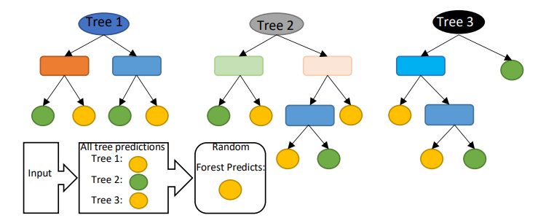

Logistic Regression (LR):
reported a study on forecasting the downtime of a printing machine based on real time predictions of imminent failures. In their study, they utilized unstructured historical machine data to train the ML classification algorithms including RF, XGBoost, and LR in predicting the machine failures. Various metrics were analyzed to determine the goodness of fit of the models. These metrics include empirical cross-entropy, area under the receiver operating characteristic curve (AUC), receiver operating characteristic curve itself (ROC), precision-recall curve (PRC), number of false positives (FP), true positives (TP), false negatives (FN), and true negatives (TN) at various decision thresholds, and calibration curves of the estimated probabilities. Based on the results obtained, in terms of ROC, all the algorithms performed significantly better and almost similar. But in terms of decision thresholds, RF and XGBoost perform better than LR. Using a given set of independent variables, linear regression is used to estimate the continuous dependent variations. However, using a given set of independent variables, logistic regression is used to estimate the categorical contingent variations [68]. Graph of the linear regression model and logistics regression model are shown in Figure 9.
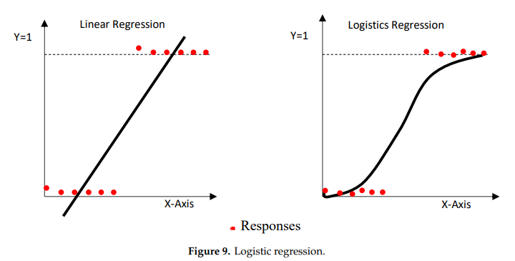

Decision Tree (DT):
Decision Tree is a network system composed primarily of nodes and branches, and nodes comprising root nodes and intermediate nodes. The intermediate nodes are used to represent a feature, and the leaf nodes are used to represent a class label [52]. DT can be used for feature selection [57]. DT algorithm is presented in Figure
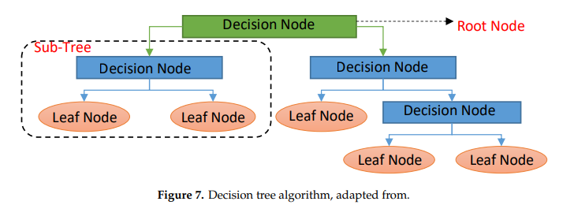
DT classifiers have gained considerable popularity in a number of areas, such as character identification, medical diagnosis, and voice recognition. More notably, the DT model has the potential to decompose a complicated decision-making mechanism into a series of simplified decisions by recursively splitting covariate space into subspaces, thereby offering a solution that is sensitive to interpretation

Support Vector Machine
A support vector machine (SVM) is a type of supervised machine learning classification algorithm which outputs an optimal hyperplane that categorizes new examples given labeled training data [15]. SVMs were introduced initially in 1960s and were later refined in 1990s. However, it is only now that they are becoming very popular, owing to their ability to achieve outstanding results.
Simple SVM: In case of linearly separable data in two dimensions, as shown in Figure 2.6, a typical machine learning algorithm tries to find a boundary that divides the data in such a way that the misclassification error can be minimized. If you closely look at Figure 2.6, there can be several boundaries that correctly divide the data points. The two dashed lines as well as one solid line classify the data correctly.

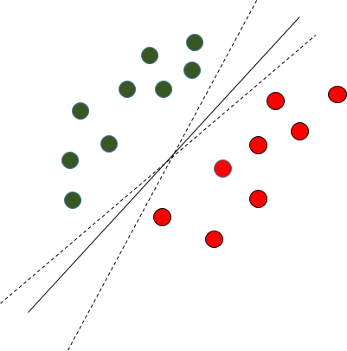

Fig. 2.6 Multiple Decision Boundaries

SVM differs from the other classification algorithms in the way that it chooses the decision boundary that maximizes the distance from the nearest data points of all the classes. An SVM doesn’t merely find a decision boundary; it finds the most optimal decision boundary. The most optimal decision boundary is the one which has maximum margin from the nearest points of all the classes. The nearest points from the decision boundary that maximize the distance between the decision boundary and the points are called support vectors as seen in Figure¬2.7. The decision boundary in case of support vector machines is called the maximum margin classifier, or the maximum margin hyper plane.
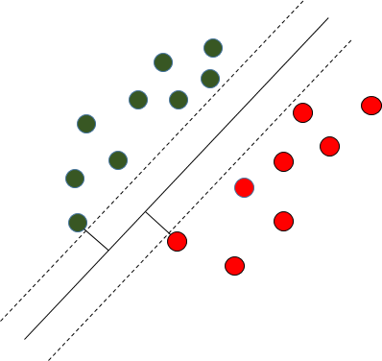
Fig. 2.7 Decision Boundary with Support Vectors
Kernel SVM: In the previous two figures Figure 2.6 and Figure 2.7 it was shown how the simple SVM algorithm can be used to find decision boundary for linearly separable data. However, in the case of non-linearly separable data, such as the one shown in Figure 2.8, a straight line cannot be used as a decision boundary.
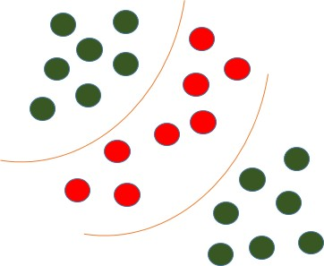
Fig. 2.8 Non-linearly Separable Data

In case of non-linearly separable data, the simple SVM algorithm cannot be used. Rather, a modified version of SVM, called Kernel SVM, is used. Basically, the kernel SVM projects the non-linearly separable data lower dimensions to linearly separable data in higher dimen- sions in such a way that data points belonging to different classes are allocated to different dimensions.

Random Forest
Random forest is a tree-based algorithm which involves building several trees (decision trees), then combining their output to improve generalization ability of the model. The method of combining trees is known as an ensemble method. Ensembling is nothing but a combination of weak learners (individual trees) to produce a strong learner.
Definition: A random forest is a classifier consisting of a collection of tree structured classifiers h(x, Θ_{k}), k = 1, ... where the Θ_{k} are independent identically distributed (i.i.d) random vectors and each tree casts a unit vote for the most popular class at input [4].
Random Forest Algorithm: The following are the basic steps involved in performing the random forest algorithm:
      - Pick N random records from the dataset.

      - Build a decision tree based on these N records.

      - Choose the number of trees you want in your algorithm and repeat steps (i) and (ii).

      - In case of a classification problem, each tree in the forest predicts the category to which the new record belongs. Finally, the new record is assigned to the category that wins the majority vote.
Figure 2.1 shows different trees labelling the class differently. What ensemble does is take the mode (maximum occurring class) of the output produced by n different trees to create a better model. To say it in simple words: Random forest builds multiple decision trees and merges them together to get a more accurate and stable prediction.

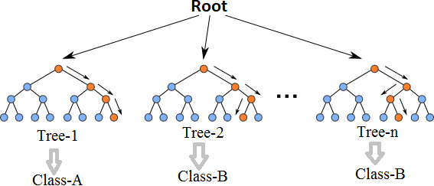

Fig. 2.1 Multiple decision trees [12]

Even though decision trees are pretty intuitive and easier to understand, they can be very noisy. Few changes in the data can lead to different splits and completely different models. The instability of the tree makes it unrealistic as a prediction model by itself. A single decision tree is insufficient and generally overfits the data, that is it can capture the structure of the in-sample data very well, but it tends to work poorly out-of-sample. In the context of statistics, decisions trees have low bias (as it can fit the data well) but high variances (the predictions are noisy).
Understanding the working principle of decision trees is imperative in the understanding of Random Forest Algorithm. The most popular algorithm for decision trees is ID3 algorithm. It finds the best attributes/features that best classifies the target attribute. One of the most commonly used way to figure out the best attribute is by calculating Information Gain which is, in turn, calculated using another property called Entropy.
The calculation of entropy of a system is done as follows:

c
Entropy(S) = ∑ p_{i}log₂ p_{i} (2.1)
−
i=1
Here, c is the total number of classes or attributes and p_{i} is number of examples belonging to the i^{th} class. Information gain is simply the expected reduction in entropy caused by partitioning all our examples according to a given attribute. Mathematically, it is defined as:
Gain(S, A) ≡ Entropy(S) − ∑ |Sv| Entropy(S_{v}) (2.2)
v∈Values(A) |S|
S refers to the entire set of examples that we have. A is the attribute we want to partition or split. |S| is the number of examples and |S_{v}| is the number of examples for the current value of attribute A. The attribute with the highest information gain sits at the root node, and the tree is first split based on that attribute.

XGBoost
XGBoost is another ensemble learning method. As it is almost never sufficient to reply upon the results of just one model, it combines the predictive powers of multiple learners to reach a conclusion. The base learners are weak learners in which the bias is high, and the predictive power is just slightly better than random guessing. But each of these weak learners add some vital information for prediction, resulting in a strong learner by effectively combining these weak learners. The final strong learner brings down both the bias and the variance.
The tree ensemble model consists of a set of classification and regression trees (CART). Figure 2.2 shows a simple example of a CART that classifies whether someone will like an

app or not. The original figure from [5] had been modified to paint a better picture of our dataset.
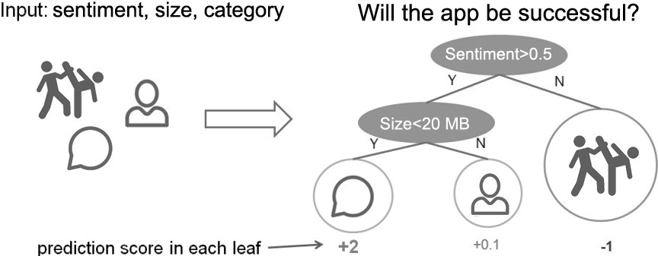
Fig. 2.2 CART Model Representation

Suppose, the many app categories available are classified into different leaves and as- signed a score on the corresponding leaf. Unlike decision trees, in which the leaf only contains decision values, in CART, a real score is associated with each of the leaves, which gives a better interpretation.
The task of training the model involves finding the best parameters θ that best fit the
training data x_{i} and labels y_{i}. This is done via the objective function which measures how well the model fits the training data. Objective functions are composed of two parts: training loss and regularization term which can be denoted by:
ob j(θ ) = L(θ ) + Ω(θ ) (2.3)

where L is the training loss function, and Ω is the regularization term. The regularization term controls the complexity of the model, helping to avoid overfitting.
While trees are built in a parallel manner in bagging, boosting builds trees sequentially such that each subsequent tree aims to reduce the errors of the previous tree. Figure 2.3 perfectly illustrates the concept. Due to each tree learning from its predecessors and updating the residual errors (difference between an observed y-value and the corresponding predicted y-value), the tree that grows next in the sequence will always learn from an updated version of the residuals. This is known as an additive strategy where what has already been learned is fixed, and a new tree is added one at a time.
The boosting process in its absolute basic can be broken down into the following steps [22]:
      - Fit a model to the data: F₁(x) = y
      - Fit a model to the residuals: h₁(x) = y − F₁(x)

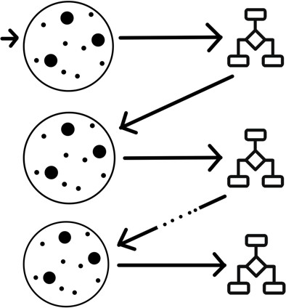

Fig. 2.3 Sequential Tree Structure

- Create a new model: F₂(x) = F₁(x) + h₁(x)
By creating more models that correct the errors of the previous models, this can be generalized to:

F(x) = F₁(X ) → F₂(x) = F₁(x) + h₁(x). . . .. → F_{M}(x) = F_{M−1}(x) + h_{M−1}(x). (2.4)
At each step, the residual would also need to be calculated: h_{m}(x) = y − F_{m}(x) where h_{m}(x) can be any model, but in our case, it is a tree-based learner. With this in mind, suppose that instead of training h₀ on the residuals of F₀, we train h₀ on the gradient of the loss function, L(y, F₀(x)) with respect to the prediction values produced by F_{m}(x). With samples in h_{m} grouped into leaves, an average gradient can be calculated and then scaled by some factor, γ, such that F_{m} + γh_{m} minimizes the loss function for the samples in each leaf. In practice, a different factor is chosen for each leaf. For iteration m = 1 to M:
- Calculate the gradient of L at the point s^{m−1}
- “Step” in the direction of greatest descent (the negative gradient) with step size γ. That is, s^{m} = s^{m−1} − γL(s^{m−1}). If γ is small and M is sufficiently large, s^{M} will be the location of L ‘s minimum value.
Most of these are true for all previous gradient boosting algorithms that came before XGBoost, but what really separates it from the others is [22]:
- Regularization: XGBoost can penalize complex models through both L1 and L2 regularization which helps prevent over-fitting.

  - Handling sparse data: Missing values or data processing steps like one-hot encoding can make data sparse. XGBoost incorporates a sparsity-aware split finding algorithm that can handle different types of sparsity patterns in the data.
  - Weighted quantile sketch: Most existing tree based algorithms can find the split points when the data points are of equal weights (using quantile sketch algorithm). However, they can not handle weighted data. XGBoost has a distributed weighted quantile sketch algorithm that can effectively handle weighted data.
  - Block structure for parallel learning: For faster computing, XGBoost can utilize multiple cores on the CPU. Unlike other algorithms, this enables the data layout to be reused by subsequent iterations, instead of computing it again.
  - Cache awareness: In XGBoost, non-continuous memory access is required to get the gradient statistics by row index. Hence, XGBoost has been designed to make optimal use of hardware.
  - Out-of-core computing: This feature optimizes the available disk space and maximizes its usage when handling huge datasets that do not fit into memory
To improve model performance, add adversity so your model can learn to recognize your target even in unlikely circumstances:
- Flip the image direction
- Incorporate images that resemble your target
- Add blurred and unsharpened versions
To improve model efficiency, reduce the model load:
- Perform max pooling in between the layers to reduce image dimensionality by compressing spatial size and parameters
- Try early stopping to prevent overfitting; if your model reaches a peak accuracy, it will stop looking for an even higher accuracy after a specific number of epochs
- Train on fewer epochs to cut the processing time
- Try a different activation function, like ReLU which only activates certain neurons, making it more efficient compared to sigmoid or tanh
- Try dropout so randomly selected neurons are ignored during training, thus creating less network computation
- Avoid large pixel images as adding more image clarity doesn’t improve learning much (224 by 224 pixels is standard)

5.3 system architecture
A system architecture or systems architecture is the conceptual model that defines the structure, behavior, and more views of a system. An architecture description is a formal description and representation of a system. Organized in a way that supports reasoning about the structures and behaviors of the system.
v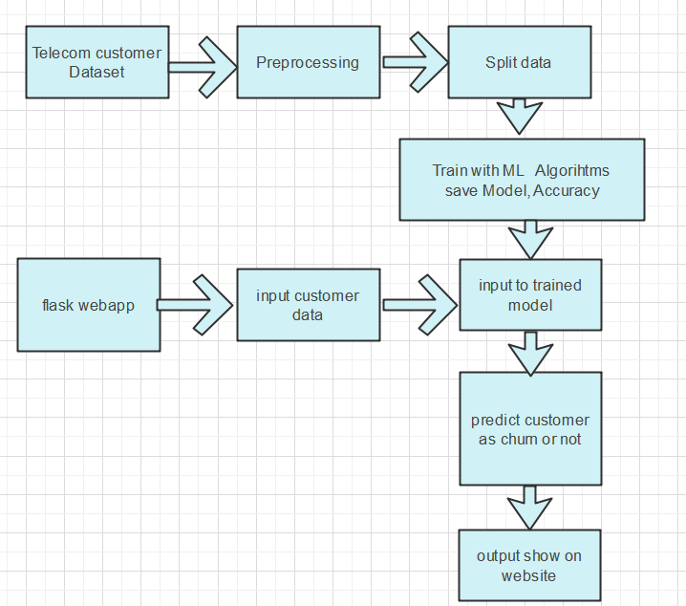Figure 5. 1 System Architecture
3-Tier Architecture:
The three-tier software architecture (a three-layer architecture) emerged in the 1990s to overcome the limitations of the two-tier architecture. The third tier (middle tier server) is between the user interface (client) and the data management (server) components. This middle tier provides process management where business logic and rules are executed and can accommodate hundreds of users (as compared to only 100 users with the two tier architecture) by providing functions such as queuing, application execution, and database staging.
The three tier architecture is used when an effective distributed client/server design is needed that provides (when compared to the two tier) increased performance, flexibility, maintainability, reusability, and scalability, while hiding the complexity of distributed processing from the user. These characteristics have made three layer architectures a popular choice for Internet applications and net-centric information systems.

Advantages of Three-Tier:

- Separates functionality from presentation.
- Clear separation – better understanding.
- Changes limited to well define components.
- Can be running on WWW.
- Effective network performance.

5.4 UML DAIGRAMS

Global Use Case Diagrams:
Identification of actors:
Actor: Actor represents the role a user plays with respect to the system. An actor interacts with, but has no control over the use cases.
Graphical representation:
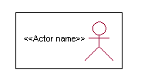

<<Actor name>>
An actor is someone or something that:
Interacts with or uses the system.
- Provides input to and receives information from the system.
- Is external to the system and has no control over the use cases.

Actors are discovered by examining:
- Who directly uses the system?
- Who is responsible for maintaining the system?
- External hardware used by the system.
- Other systems that need to interact with the system.

Questions to identify actors:
  - Who is using the system? Or, who is affected by the system? Or, which groups need help from the system to perform a task?
  - Who affects the system? Or, which user groups are needed by the system to perform its functions? These functions can be both main functions and secondary functions such as administration.
  - Which external hardware or systems (if any) use the system to perform tasks?
  - What problems does this application solve (that is, for whom)?
  - And, finally, how do users use the system (use case)? What are they doing with the system?
The actors identified in this system are:
- System Administrator
- Customer
- Customer Care
Identification of use cases:
Use case: A use case can be described as a specific way of using the system from a user’s (actor’s) perspective.
Graphical representation:
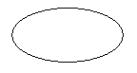
A more detailed description might characterize a use case as:
- Pattern of behavior the system exhibits
- A sequence of related transactions performed by an actor and the system
- Delivering something of value to the actor

Use cases provide a means to:
- capture system requirements
- communicate with the end users and domain experts
- test the system
Use cases are best discovered by examining the actors and defining what the actor will be able to do with the system.
Guide lines for identifying use cases:
- For each actor, find the tasks and functions that the actor should be able to perform or that the system needs the actor to perform. The use case should represent a course of events that leads to clear goal
- Name the use cases.
- Describe the use cases briefly by applying terms with which the user is familiar.
This makes the description less ambiguous
Questions to identify use cases:
- What are the tasks of each actor?
- Will any actor create, store, change, remove or read information in the system?
- What use case will store, change, remove or read this information?
- Will any actor need to inform the system about sudden external changes?
- Does any actor need to inform about certain occurrences in the system?
- What usecases will support and maintains the system?

1.2 Flow of Events
A flow of events is a sequence of transactions (or events) performed by the system. They typically contain very detailed information, written in terms of what the system should do, not how the system accomplishes the task. Flow of events are created as separate files or documents in your favorite text editor and then attached or linked to a use case using the Files tab of a model element.
A flow of events should include:
- When and how the use case starts and ends
- Use case/actor interactions
- Data needed by the use case
- Normal sequence of events for the use case
- Alternate or exceptional flows

5.4.1 Construction of Use case diagrams:

FLOW CHART:

A use case diagram in the Unified Modeling Language (UML) is a type of behavioral diagram defined by and created from a Use-case analysis. Its purpose is to present a graphical overview of the functionality provided by a system in terms of actors, their goals (represented as use cases), and any dependencies between those use cases. The main purpose of a use case diagram is to show what system functions are performed for which actor. Roles of the actors in the system can be depicted.
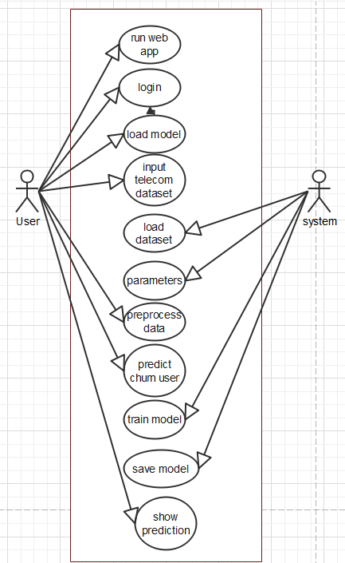

Figure 5. 2 Use Case Diagram

5.4.2 SEQUENCE DIAGRAMS:
A sequence diagram in Unified Modeling Language (UML) is a kind of interaction diagram that shows how processes operate with one another and in what order. It is a construct of a Message Sequence Chart. Sequence diagrams are sometimes called event diagrams, event scenarios, and timing diagrams.

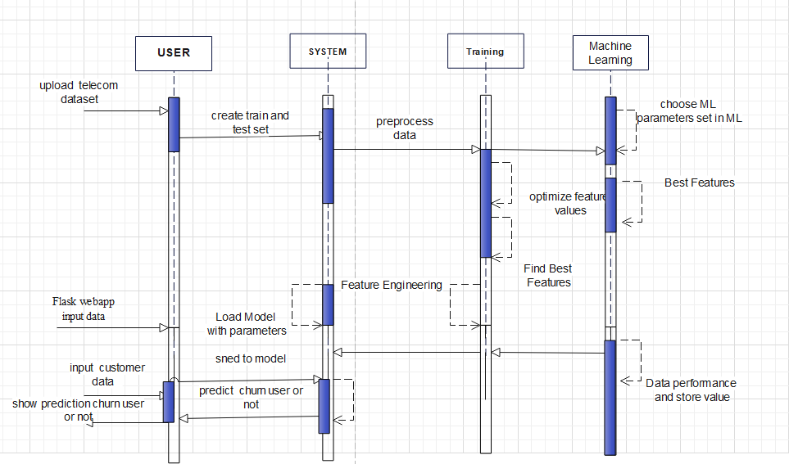
Figure 5. 3 Sequence diagram

5.4.3 CLASS DIAGRAM:
In software engineering, a class diagram in the Unified Modeling Language (UML) is a type of static structure diagram that describes the structure of a system by showing the system's classes, their attributes, operations (or methods), and the relationships among the classes. It explains which class contains information.

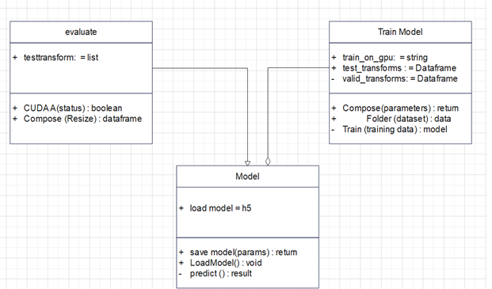
Figure 5. 4 Class Diagram

5.4.4 ACTIVITY DIAGRAM:
Activity diagrams are graphical representations of workflows of stepwise activities and actions with support for choice, iteration and concurrency. In the Unified Modeling Language, activity diagrams can be used to describe the business and operational step-by-step workflows of components in a system. An activity diagram shows the overall flow of control.

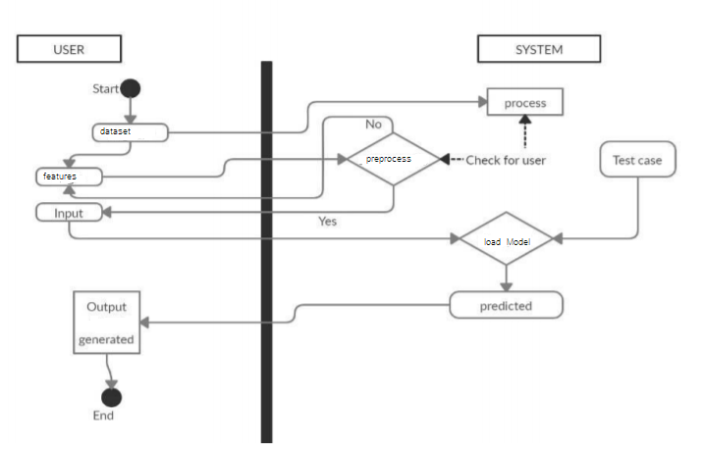
Figure 5. 5 Activity Diagram

CHAPTER-6

system requirements

6.1 SYSTEM REQUIREMENTS

6.1.1 HARDWARE REQUIREMENTS:
- System : Intel(R) Core(TM) i3-7020U CPU @ 2.30GHz
- Hard Disk : 1 TB.
- Input Devices : Keyboard, Mouse
- Ram : 4 GB.

6.1.2 SOFTWARE REQUIREMENTS:
- Operating system : Windows XP/7/10.
- Coding Language : Python
- Tool : Anaconda
- Interface : flask jupyter notebook

Chapter-7

System implementation
To conduct studies and analyses of an operational and technological nature, and To promote the exchange and development of methods and tools for operational analysis as applied to defense problems.

7.1 input and output designs

7.1.1 Logical design
The logical design of a system pertains to an abstract representation of the data flows, inputs and outputs of the system. This is often conducted via modeling, using an over-abstract (and sometimes graphical) model of the actual system. In the context of systems design are included. Logical design includes ER Diagrams i.e. Entity Relationship Diagrams

7.1.2 Physical design
The physical design relates to the actual input and output processes of the system. This is laid down in terms of how data is input into a system, how it is verified / authenticated, how it is processed, and how it is displayed as output. In Physical design, following requirements about the system are decided.
- Input requirement,
- Output requirements,
- Storage requirements,
- Processing Requirements,
- System control and backup or recovery.
Put another way, the physical portion of systems design can generally be broken down into three sub-tasks:
- User Interface Design
- Data Design
- Process Design
User Interface Design is concerned with how users add information to the system and with how the system presents information back to them. Data Design is concerned with how the data is represented and stored within the system. Finally, Process Design is concerned with how data moves through the system, and with how and where it is validated, secured and/or transformed as it flows into, through and out of the system. At the end of the systems design phase, documentation describing the three sub-tasks is produced and made available for use in the next phase.
Physical design, in this context, does not refer to the tangible physical design of an information system. To use an analogy, a personal computer's physical design involves input via a keyboard, processing within the CPU, and output via a monitor, printer, etc. It would not concern the actual layout of the tangible hardware, which for a PC would be a monitor, CPU, motherboard, hard drive, modems, video/graphics cards, USB slots, etc. It involves a detailed design of a user and a product database structure processor and a control processor. The H/S personal specification is developed for the proposed system.

7.2 INPUT & OUTPUT REPRESENTATION

7.2.1 Input Design

The input design is the link between the information system and the user. It comprises the developing specification and procedures for data preparation and those steps are necessary to put transaction data in to a usable form for processing can be achieved by inspecting the computer to read data from a written or printed document or it can occur by having people keying the data directly into the system. The design of input focuses on controlling the amount of input required, controlling the errors, avoiding delay, avoiding extra steps and keeping the process simple. The input is designed in such a way so that it provides security and ease of use with retaining the privacy. Input Design considered the following things:
- What data should be given as input?
- How the data should be arranged or coded?
- The dialog to guide the operating personnel in providing input.
- Methods for preparing input validations and steps to follow when error occur.

7.2.2 Objectives
Input Design is the process of converting a user-oriented description of the input into a computer-based system. This design is important to avoid errors in the data input process and show the correct direction to the management for getting correct information from the computerized system.
It is achieved by creating user-friendly screens for the data entry to handle large volume of data. The goal of designing input is to make data entry easier and to be free from errors. The data entry screen is designed in such a way that all the data manipulates can be performed. It also provides record viewing facilities.
When the data is entered it will check for its validity. Data can be entered with the help of screens. Appropriate messages are provided as when needed so that the user will not be in maize of instant. Thus the objective of input design is to create an input layout that is easy to follow

Output Design

A quality output is one, which meets the requirements of the end user and presents the information clearly. In any system results of processing are communicated to the users and to other system through outputs. In output design it is determined how the information is to be displaced for immediate need and also the hard copy output. It is the most important and direct source information to the user. Efficient and intelligent output design improves the system’s relationship to help user decision-making.
  - Designing computer output should proceed in an organized, well thought out manner; the right output must be developed while ensuring that each output element is designed so that people will find the system can use easily and effectively. When analysis design computer output, they should Identify the specific output that is needed to meet the requirements.
  - Select methods for presenting information.
  - Create document, report, or other formats that contain information produced by the system.

Code

<!doctype html>
<html lang="en">

<head>
<!-- Required meta tags -->
<meta charset="utf-8">
<meta name="viewport" content="width=device-width, initial-scale=1, shrink-to-fit=no">
<!-- Bootstrap CSS -->
<link rel="stylesheet" href="https://maxcdn.bootstrapcdn.com/bootstrap/4.0.0/css/bootstrap.min.css" integrity="sha384-Gn5384xqQ1aoWXA+058RXPxPg6fy4IWvTNh0E263XmFcJlSAwiGgFAW/dAiS6JXm" crossorigin="anonymous">
<title>Home</title>
</head>
<nav class="navbar navbar-dark bg-dark navbar-fixed-top">
<a class="navbar-brand" href="#">Employee Churn Prediction</a>
<button class="navbar-toggler" type="button" data-toggle="collapse" data-target="#navbarNav" aria-controls="navbarNav" aria-expanded="false" aria-label="Toggle navigation">
<span class="navbar-toggler-icon"></span>
</button>
<div class="collapse navbar-collapse" id="navbarNav">
<ul class="navbar-nav">
<li class="nav-item active">
<a class="nav-link" href="/">Home</a>
</li>
<li class="nav-item">

</li>
</ul>
</div>
</nav>
<body>

<form action="/" method="POST">
<fieldset>
<center>
<div class="form">
<label for="Dependents">Dependents:</label><br>
<input style="background-color: rgb(255, 255, 255);" type="text" name="Dependents" id="Dependents" value="" ><br>

<label for="tenure">tenure:</label><br>
<input style="background-color: rgb(245, 244, 241);" type="number" name="tenure" id="tenure" value=""/><br>

<label for="OnlineSecurity"> OnlineSecurity:</label><br>
<input style="background-color: rgb(249, 249, 245);" type="text" name="OnlineSecurity" id="OnlineSecurity" value=""><br>

<label for="OnlineBackup">OnlineBackup:</label><br>
<input style="background-color: rgb(254, 253, 249);" type="text" name="OnlineBackup" id="OnlineBackup" value=""><br>

<label for="DeviceProtection">DeviceProtection:</label><br>
<input style="background-color: rgb(247, 247, 245);" type="text" name="DeviceProtection" id="DeviceProtection" value=""><br>

<label for="TechSupport">TechSupport:</label><br>
<input style="background-color: rgb(239, 239, 233);" type="text" name="TechSupport" id="TechSupport" value=""><br>

<label for="Contract">Contract:</label><br>
<input style="background-color: rgb(246, 245, 239);" type="text" name="Contract" id="Contract" value=""><br>

<label for="PaperlessBilling">PaperlessBilling:</label><br>
<input style="background-color: rgb(235, 235, 234);" type="text" name="PaperlessBilling" id="PaperlessBilling" value=""><br>

<label for="MonthlyCharges">MonthlyCharges:</label><br>
<input style="background-color: rgb(251, 250, 245);" type="text" name="MonthlyCharges" id="MonthlyCharges" value=""><br>

<label for="TotalCharges">TotalCharges:</label><br>
<input style="background-color: rgb(239, 238, 232);" type="text" name="TotalCharges" id="TotalCharges" value=""><br>
</div>

<div class="col-sm-3">
<button style="background-color:rgb(240, 230, 230);border-color:powderblue;color:white" type="submit" class="btn btn-primary" name="submit">SUBMIT</button>
</div>
</center>
</fieldset>

</form>

</div>
</div>
<!-- Optional JavaScript -->
<!-- jQuery first, then Popper.js, then Bootstrap JS -->
<script src="https://code.jquery.com/jquery-3.2.1.slim.min.js" integrity="sha384-KJ3o2DKtIkvYIK3UENzmM7KCkRr/rE9/Qpg6aAZGJwFDMVNA/GpGFF93hXpG5KkN" crossorigin="anonymous"></script>
<script src="https://cdnjs.cloudflare.com/ajax/libs/popper.js/1.12.9/umd/popper.min.js" integrity="sha384-ApNbgh9B+Y1QKtv3Rn7W3mgPxhU9K/ScQsAP7hUibX39j7fakFPskvXusvfa0b4Q" crossorigin="anonymous"></script>
<script src="https://maxcdn.bootstrapcdn.com/bootstrap/4.0.0/js/bootstrap.min.js" integrity="sha384-JZR6Spejh4U02d8jOt6vLEHfe/JQGiRRSQQxSfFWpi1MquVdAyjUar5+76PVCmYl" crossorigin="anonymous"></script>
<div class="form">
<center><br>
<output> <strong>{{op1}}</strong></output><br><output><strong>{{op2}}</strong></output>
</center>
</div>

</body>
<style>
body {
background-color: #626269;
}

.col-lg-4 {
color: #ffffff;
}
</style>

</html>

import numpy as np
import pandas as pd
from sklearn.preprocessing import LabelEncoder
import pickle
from flask import Flask, request, render_template

app = Flask(__name__)

@app.route("/")
def home_page():
return render_template('home.html')

@app.route("/", methods=['POST'])
def predict():

""" Selected feature are Dependents, tenure, OnlineSecurity,
OnlineBackup, DeviceProtection, TechSupport, Contract,
PaperlessBilling, MonthlyCharges, TotalCharges """

Dependents = request.form['Dependents']
tenure = float(request.form['tenure'])
OnlineSecurity = request.form['OnlineSecurity']
OnlineBackup = request.form['OnlineBackup']
DeviceProtection = request.form['DeviceProtection']
TechSupport = request.form['TechSupport']
Contract = request.form['Contract']
PaperlessBilling = request.form['PaperlessBilling']
MonthlyCharges = float(request.form['MonthlyCharges'])
TotalCharges = float(request.form['TotalCharges'])

model = pickle.load(open('Model.sav', 'rb'))
data = [[Dependents, tenure, OnlineSecurity, OnlineBackup, DeviceProtection, TechSupport, Contract, PaperlessBilling, MonthlyCharges, TotalCharges]]
df = pd.DataFrame(data, columns=['Dependents', 'tenure', 'OnlineSecurity',
'OnlineBackup', 'DeviceProtection', 'TechSupport', 'Contract',
'PaperlessBilling', 'MonthlyCharges', 'TotalCharges'])

categorical_feature = {feature for feature in df.columns if df[feature].dtypes == 'O'}

encoder = LabelEncoder()
for feature in categorical_feature:
df[feature] = encoder.fit_transform(df[feature])

single = model.predict(df)
probability = model.predict_proba(df)[:, 1]
probability = probability*100

if single == 1:
op1 = "This Customer is likely to be Churned!"
op2 = f"Confidence level is {np.round(probability[0], 2)}"
else:
op1 = "This Customer is likely to be Continue!"
op2 = f"Confidence level is {np.round(probability[0], 2)}"

return render_template("home.html", op1=op1, op2=op2,
Dependents=request.form['Dependents'],
tenure=request.form['tenure'],
OnlineSecurity=request.form['OnlineSecurity'],
OnlineBackup=request.form['OnlineBackup'],
DeviceProtection=request.form['DeviceProtection'],
TechSupport=request.form['TechSupport'],
Contract=request.form['Contract'],
PaperlessBilling=request.form['PaperlessBilling'],
MonthlyCharges=request.form['MonthlyCharges'],
TotalCharges=request.form['TotalCharges'])

if __name__ == '__main__':
app.run()

Initialize libraries:

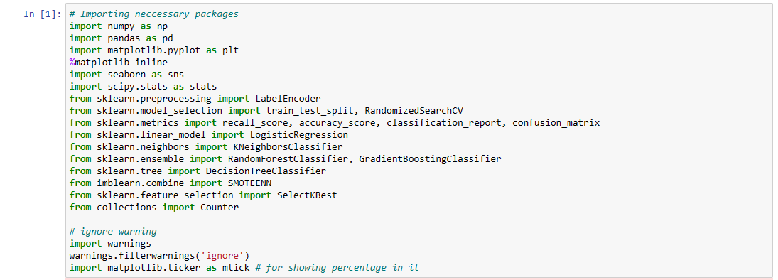

In this step multiple python libraries are imported using import statement. These libraries are used for data handling, pre-processing, Training models , data analysis and feature extraction. Sklearn is main class for all machine learning algorithms which is imported in this step.
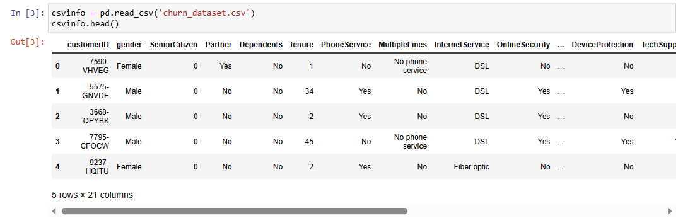
In this step we are reading churn csv file data set from system folder which is loaded using pandas’ object. Data set consists of features and labels customer id, gender, senior citizen, partner all these are features which are used as input for prediction whereas for these features if a customer is churn user or not is label which is yes and No. Yes, means customer will leave network no means customer will note leave company.
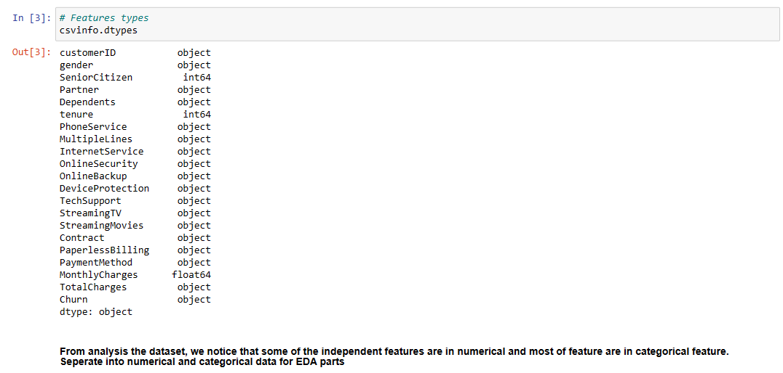
After reading dataset with pandas each feature data type is calculated which shows object and int and float as variable types.
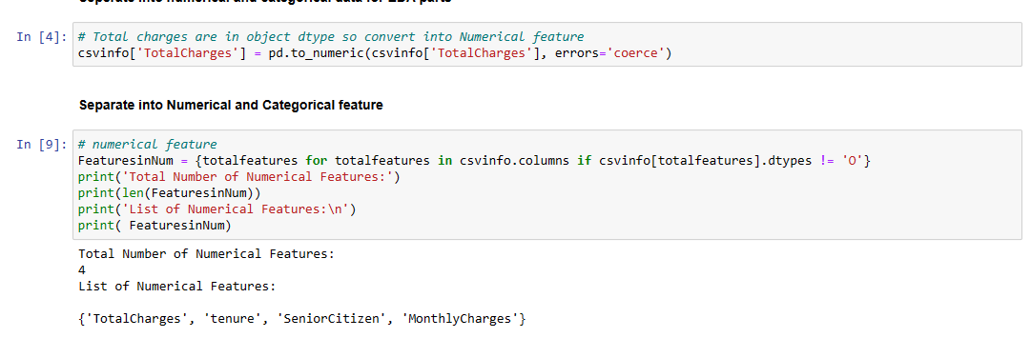
For easy pre-processing of data, data read from csv file is divided in to numerical and categorical features. All numerical features are copied in to featuresinNum variable we can see there are four types of number features like total charges, tenure, senior citizen, monthly charges.
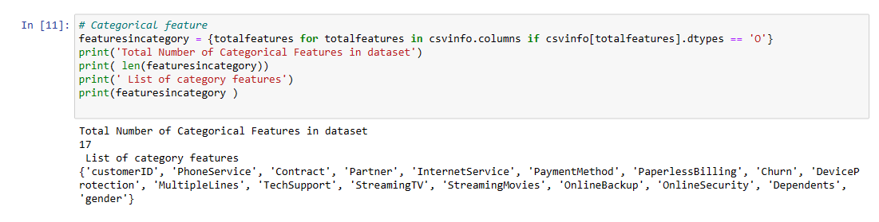
After numerical features we are dividing categorical features from the dataset as we can see there are 17 categorical features in the dataset which are customer id, phone service, contract. Etc

Data analysis part to show in depth analysis of each feature and its distribution in the dataset. From above graph total count of churn with yes and no values are compared. Graph shows total number of churn and non-churn users in the dataset which are 2000 and 5000
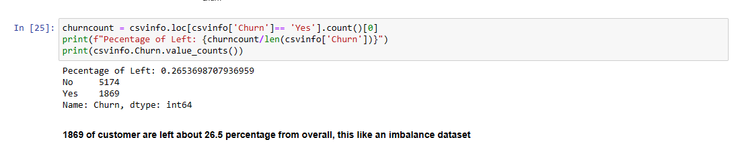
Exact count of churn users with yes and no is displayed in this section.
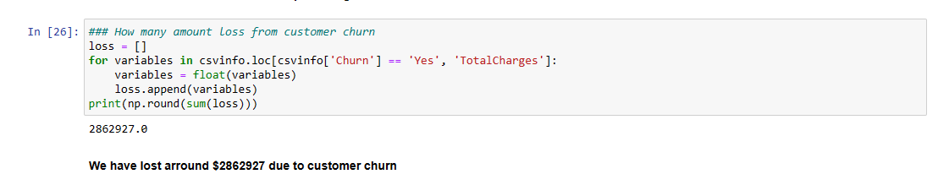
In this calculation total amount of loss company faced from customer churn is calculated which gives idea how churn customers will affect company. From above conclusion company has lost $2862927 dollars from churn

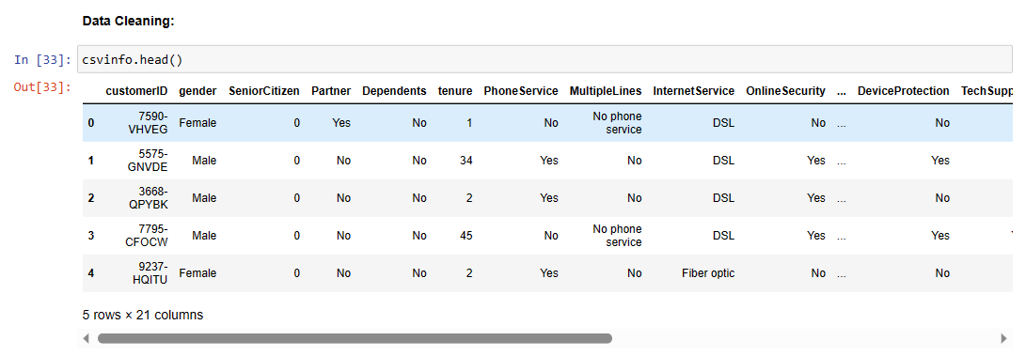
In this step data cleaning is applied to the dataset before training with algorithm.
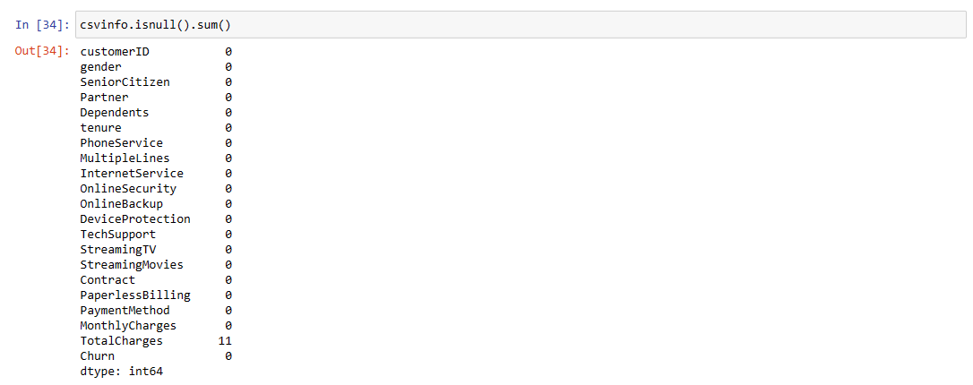
From total dataset total charges features has more null values remaining all features has 0 null values.

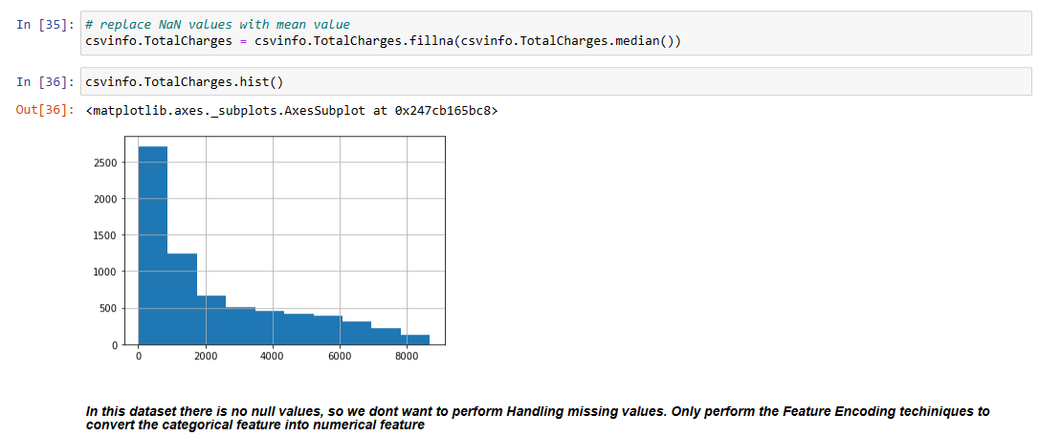
As there are not null values in the dataset there is no need of performing handling missing values where as feature encoding is applied to convert the categorical features in to numerical features.
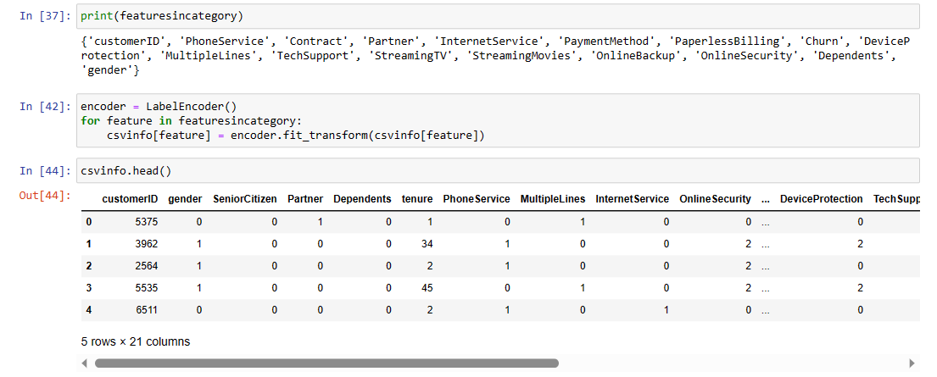
List of categorical features are displayed which are to be converted in to numerical values. In order to train algorithm data should be in numerical form so label encode is used to convert each categorical feature in to numerical.

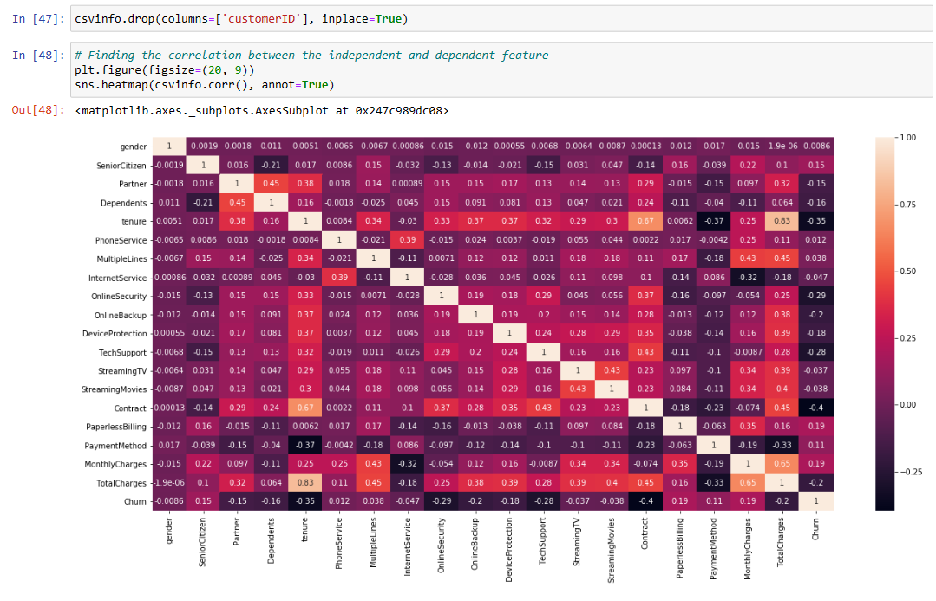
Heat map shows distribution of feature importance by comparing total numerical and categorical features with values of importance and their effect on perdition.

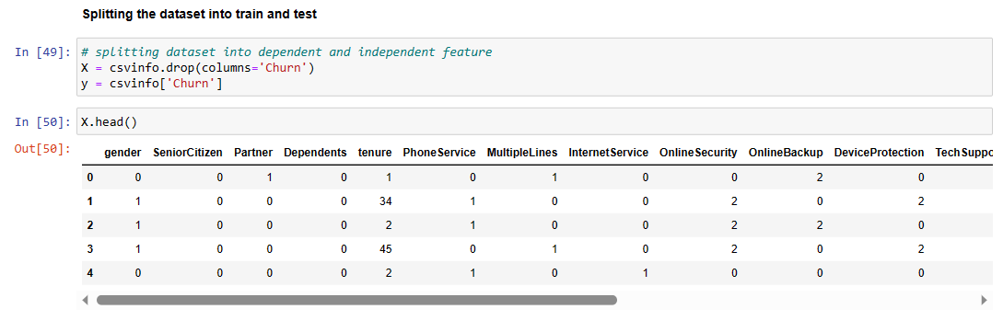Pre processed data is converted in to features and labels which users churn as label and other factors as features, features are copied in to x variable and label sin to y variable.
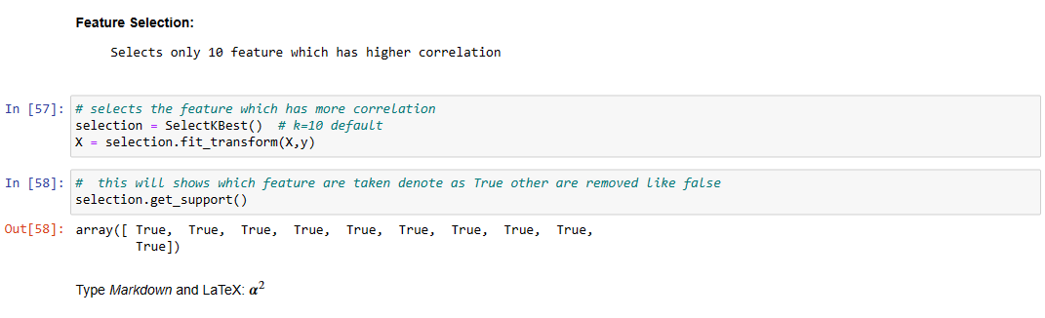
As shown in the heatmap each feature will have different importance feature to find out which feature is more important we are using selectbest feature function to find out high correlation values results shows there are 10 features which are more important.
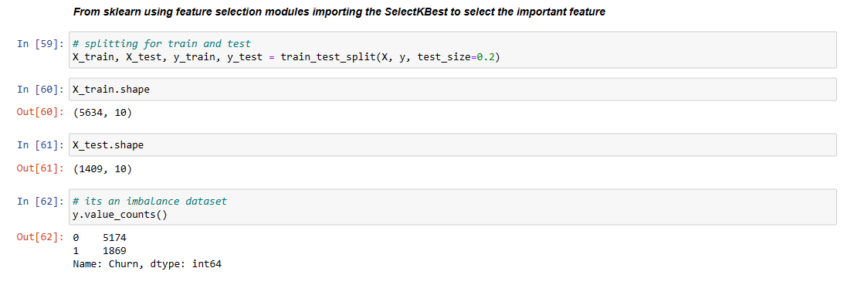
To train and test data dataset is divided in to training and testing sets which hare divided in 80/20 training has 80 and testing has 20. Training data is used to fit to model where are testing data is used to calculate accuracy of the model.
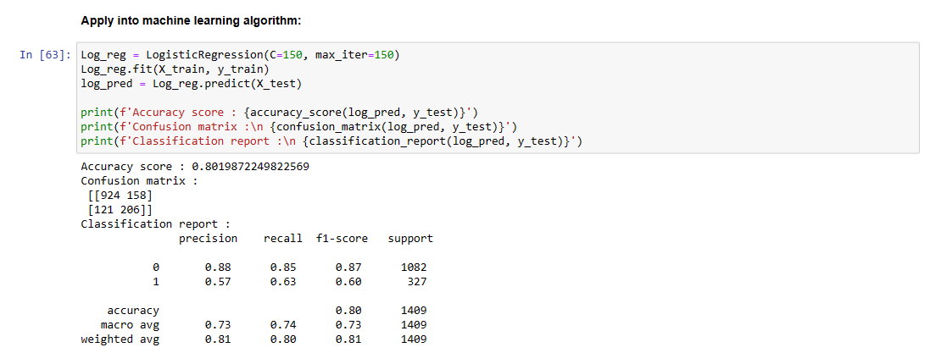
In this step training and testing data set is used to train with logistic regression method which will take training data as input and testing data as output. Training accuracy of this model is 80 percent
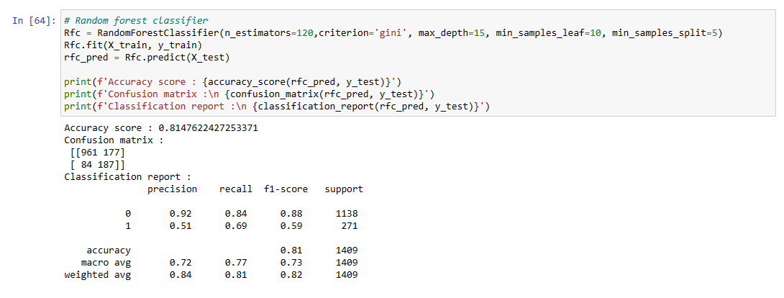
In this step training and testing data set is used to train with Random Forest classifier method which will take training data as input and testing data as output. Training accuracy of this model is 81 percent

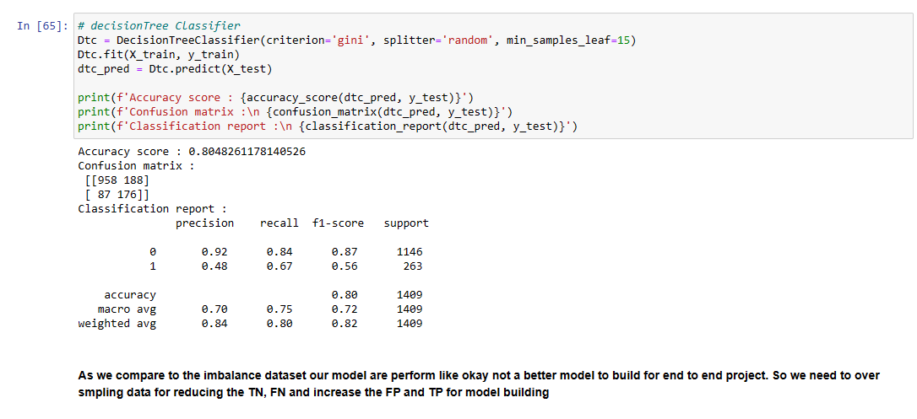
In this step training and testing data set is used to train with Decision Tree classifier method which will take training data as input and testing data as output. Training accuracy of this model is 80 percent

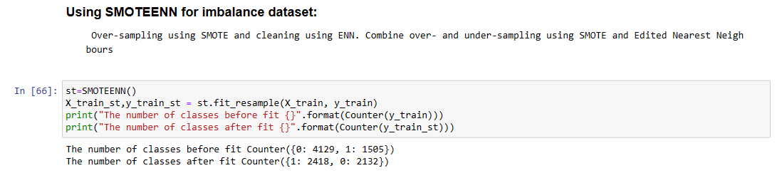
To improve accuracy of the model dataset is equally distributed with smotenn function. After applying smoteenn function number of classes before fit counter is 0:4129 for 1 1505 where as after applying fit counter it is equally distributed 1 2418 0 2132
After applying smote function dataset is split in to training and testing set and again trained with multiple algorithms to check improve in accuracy of the model.
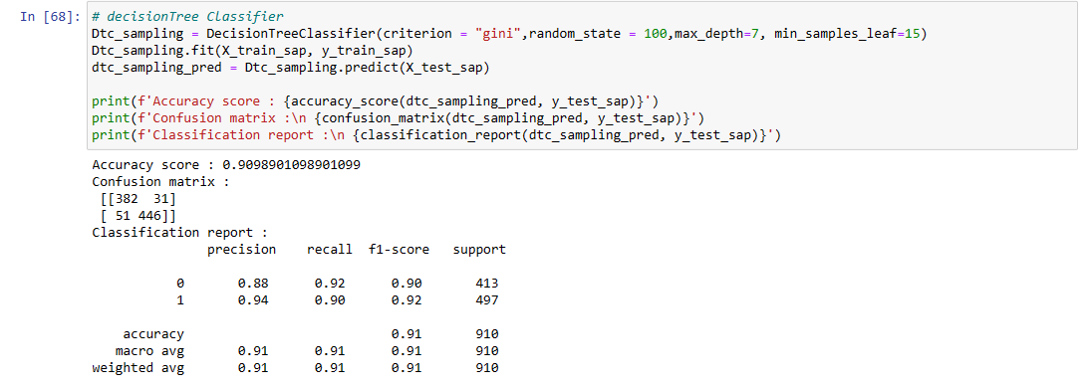
In this step training and testing data set after applying smote is used to train with Decision classifier method which will take training data as input and testing data as output. Training accuracy of this model is 91 percent we can see before smote accuracy was 80 percent after applying accuracy is 91 percent.

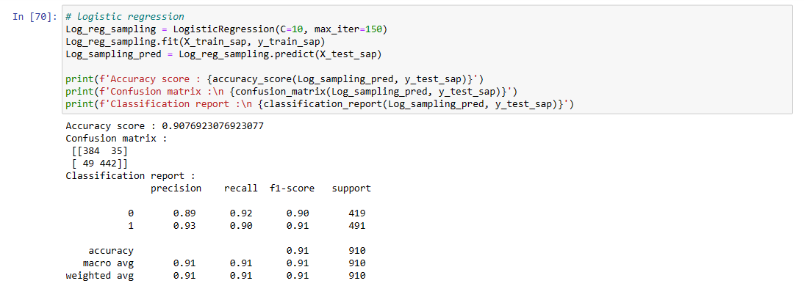
In this step training and testing data set after applying smote is used to train with Logistic Regression classifier method which will take training data as input and testing data as output. Training accuracy of this model is 91 percent we can see before smote accuracy was 80 percent after applying accuracy is 91 percent.

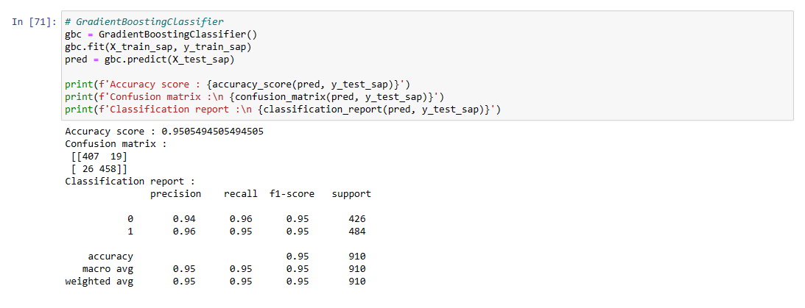
In this step training and testing data set after applying smote is used to train with gradient boosting classifier method which will take training data as input and testing data as output. Training accuracy of this model is 95 percent we can see before smote accuracy was 80 percent after applying accuracy is 95 percent.

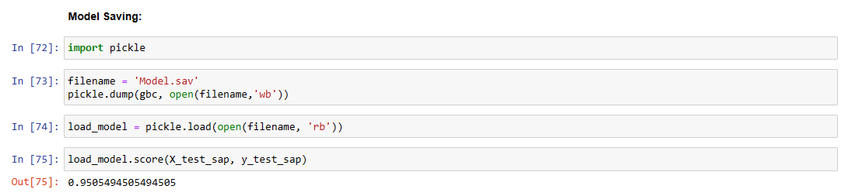
After training with multiple models gradient boosting classifier is giving more accuracy so this model is used for predicting churn users. In this step trained model is saved in pickle format.
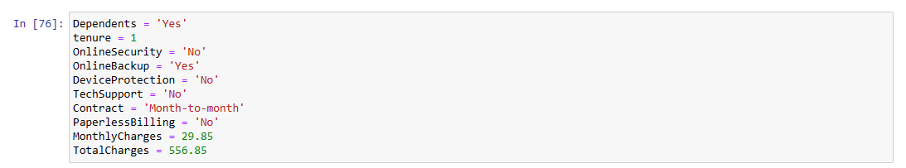
Final features with sample data is given as input to variable and used to test if user with these features can be churn user or not by giving input to trained model and predicting result
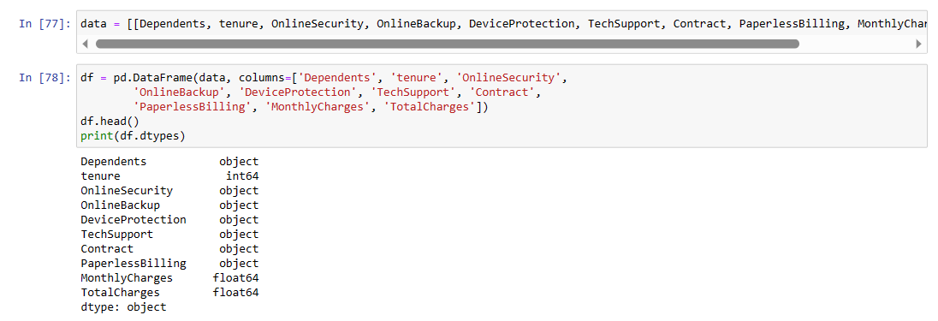
Each variable data is store din to single data structure with name data and data type of each feature are shown.
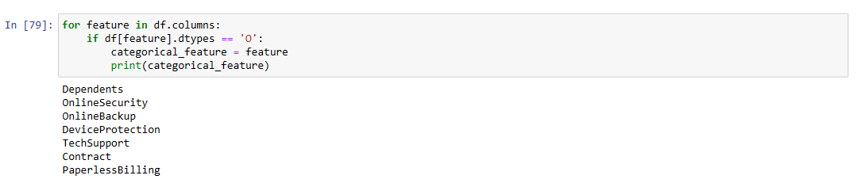
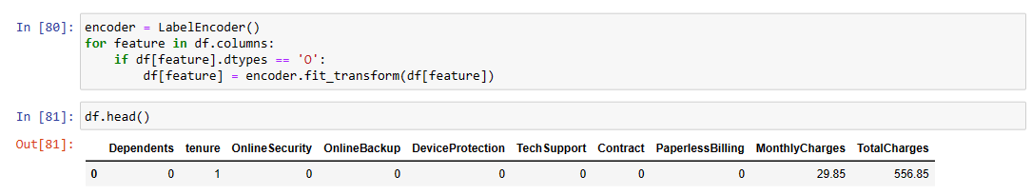
In this step input data is converted to integers by applying label encode function which is given as input to model.

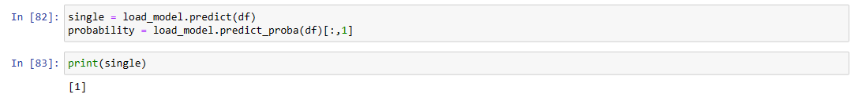
Predicted result is 0 or 1, sfor given input output is 1 which shows customer with given input can be churn customer

Chapter-8

System testing

8.1 INTRODUCTION:
Testing is the debugging program is one of the most critical aspects of the computer programming triggers, without programming that works, the system would never produce an output of which it was designed. Testing is best performed when user development is asked to assist in identifying all errors and bugs. The sample data are used for testing. It is not quantity but quality of the data used the matters of testing. Testing is aimed at ensuring that the system was accurately an efficiently before live operation commands.
Testing objectives:
The main objective of testing is to uncover a host of errors, systematically and with minimum effort and time. Stating formally, we can say, testing is a process of executing a program with intent of finding an error.
- A successful test is one that uncovers an as yet undiscovered error.
- A good test case is one that has probability of finding an error, if it exists.
- The test is inadequate to detect possibly present errors.
- The software more or less confirms to the quality and reliable standards.

8.2 Levels of Testing
Code testing:
This examines the logic of the program. For example, the logic for updating various sample data and with the sample files and directories were tested and verified.
Specification Testing:
Executing this specification starting what the program should do and how it should performed under various conditions. Test cases for various situation and combination of conditions in all the modules are tested.
Unit testing:
In the unit testing we test each module individually and integrate with the overall system. Unit testing focuses verification efforts on the smallest unit of software design in the module. This is also known as module testing. The module of the system is tested separately. This testing is carried out during programming stage itself. In the testing step each module is found to work satisfactorily as regard to expected output from the module. There are some validation checks for fields also. For example, the validation check is done for varying the user input given by the user which validity of the data entered. It is very easy to find error debut the system.
Each Module can be tested using the following two Strategies:
- Black Box Testing
- White Box Testing

8.2.1 BLACK BOX TESTING

What is Black Box Testing?
Black box testing is a software testing techniques in which functionality of the software under test (SUT) is tested without looking at the internal code structure, implementation details and knowledge of internal paths of the software. This type of testing is based entirely on the software requirements and specifications.
In Black Box Testing we just focus on inputs and output of the software system without bothering about internal knowledge of the software program.
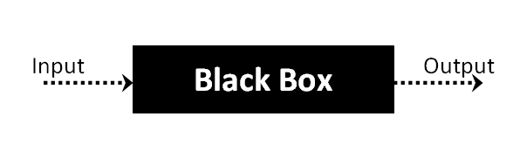
The above Black Box can be any software system you want to test. For example : an operating system like Windows, a website like Google ,a database like Oracle or even your own custom application. Under Black Box Testing , you can test these applications by just focusing on the inputs and outputs without knowing their internal code implementation.
Black box testing - Steps
Here are the generic steps followed to carry out any type of Black Box Testing.
- Initially requirements and specifications of the system are examined.
- Tester chooses valid inputs (positive test scenario) to check whether SUT processes them correctly. Also some invalid inputs (negative test scenario) are chosen to verify that the SUT is able to detect them.
- Tester determines expected outputs for all those inputs.
- Software tester constructs test cases with the selected inputs.
- The test cases are executed.
- Software tester compares the actual outputs with the expected outputs.
- Defects if any are fixed and re-tested.
Types of Black Box Testing
There are many types of Black Box Testing but following are the prominent ones -
- Functional testing – This black box testing type is related to functional requirements of a system; it is done by software testers.
- Non-functional testing – This type of black box testing is not related to testing of a specific functionality, but non-functional requirements such as performance, scalability, usability.
- Regression testing – Regression testing is done after code fixes , upgrades or any other system maintenance to check the new code has not affected the existing code.

8.2.2 WHITE BOX TESTING
White Box Testing is the testing of a software solution's internal coding and infrastructure. It focuses primarily on strengthening security, the flow of inputs and outputs through the application, and improving design and usability.White box testing is also known as clear, open, structural, and glass box testing.
It is one of two parts of the "box testing" approach of software testing. Its counter-part, blackbox testing, involves testing from an external or end-user type perspective. On the other hand, Whitebox testing is based on the inner workings of an application and revolves around internal testing. The term "whitebox" was used because of the see-through box concept. The clear box or whitebox name symbolizes the ability to see through the software's outer shell (or "box") into its inner workings. Likewise, the "black box" in "black box testing" symbolizes not being able to see the inner workings of the software so that only the end-user experience can be tested
WHAT DO YOU VERIFY IN WHITE BOX TESTING?
White box testing involves the testing of the software code for the following:
- Internal security holes
- Broken or poorly structured paths in the coding processes
- The flow of specific inputs through the code
- Expected output
- The functionality of conditional loops
- Testing of each statement, object and function on an individual basis

The testing can be done at system, integration and unit levels of software development. One of the basic goals of whitebox testing is to verify a working flow for an application. It involves testing a series of predefined inputs against expected or desired outputs so that when a specific input does not result in the expected output, you have encountered a bug.
HOW DO YOU PERFORM WHITE BOX TESTING?
To give you a simplified explanation of white box testing, we have divided it into two basic steps. This is what testers do when testing an application using the white box testing technique:
STEP 1) UNDERSTAND THE SOURCE CODE
The first thing a tester will often do is learn and understand the source code of the application. Since white box testing involves the testing of the inner workings of an application, the tester must be very knowledgeable in the programming languages used in the applications they are testing. Also, the testing person must be highly aware of secure coding practices. Security is often one of the primary objectives of testing software. The tester should be able to find security issues and prevent attacks from hackers and naive users who might inject malicious code into the application either knowingly or unknowingly.
Step 2) CREATE TEST CASES AND EXECUTE
The second basic step to white box testing involves testing the application’s source code for proper flow and structure. One way is by writing more code to test the application’s source code. The tester will develop little tests for each process or series of processes in the application. This method requires that the tester must have intimate knowledge of the code and is often done by the developer. Other methods include manual testing, trial and error testing and the use of testing tools as we will explain further on in this article.

Unit testing:

Sl # Test Case : | UTC1
Name of Test: | Load dataset
Items being tested: | Dataset features and labels are displayed or not
Sample Input: | Dataset of telecom customers
Expected output: | All features and labels should be displayed
Actual output: | Total data is displayed
Remarks: | Pass.

Sl # Test Case : | UTC2
Name of Test: | Split data
Items being tested: | Data is divided in to train and test set
Sample Input: | Test and train size
Expected output: | Dataset is divided in to 2 parts
Actual output: | Based on given test size data is divided and stored in train and test sets
Remarks: | pass

Integration Testing:

Integration testing is a level of software testing where individual units are combined and tested as a group. The purpose of this level of testing is to expose faults in the interaction between integrated units. Test drivers and test stubs are used to assist in Integration Testing. Integration testing is defined as the testing of combined parts of an application to determine if they function correctly. It occurs after unit testing and before validation testing. Integration testing can be done in two ways: Bottom­up integration testing and Top­down integration testing.

Bottom­up Integration

This testing begins with unit testing, followed by tests of progressively higher­level combinations of units called modules or builds.

Top­down Integration

In this testing, the highest­level modules are tested first and progressively, lower­level modules are tested thereafter.
In a comprehensive software development environment, bottom­up testing is usually done first, followed by top­down testing. The process concludes with multiple tests of the complete application, preferably in scenarios designed to mimic actual situations. Table 6.5 shows the test cases for integration testing and their results

Sl # Test Case : | ITC1
Name of Test: | Train Model
Item being tested: | Model fit is performed
Sample Input: | Train x and train y
Expected output: | Fit is performed
Actual output: | Training is done and accuracy is displayed
Remarks: | Pass.

Sl # Test Case : | ITC2
Name of Test: | Accuracy calculation
Item being tested: | If accuracy of each algorithm is calculated
Sample Input: | Test x and test y
Expected output: | Accuracy of each algorithm
Actual output: | Accuracy of each model
Remarks: | Pass.

System testing:

System testing of software or hardware is testing conducted on a complete, integrated system to evaluate the system's compliance with its specified requirements. System testing falls within the scope of black­box testing, and as such, should require no knowledge of the inner design of the code or logic. System testing is important because of the following reasons:

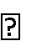
System testing is the first step in the Software Development Life Cycle, where the application is tested as a whole.

The application is tested thoroughly to verify that it meets the functional and technical specifications.
The application is tested in an environment that is very close to the production environment where the application will be deployed.

System testing enables us to test, verify, and validate both the business requirements as well as the application architecture.
System Testing is shown in below tables

Sl # Test Case : ­ | STC­1
Name of Test: ­ | System testing in various versions of OS
Item being tested: ­ | OS compatibility.
Sample Input: ­ | Execute the program in windows XP/ Windows­7/8
Expected output: ­ | Performance is better in windows­7
Actual output: ­ | Same as expected output, performance is better in windows­7
Remarks: ­ | Pass

CHAPTER-9

Output Screens

9.1 Dataset SCREEN
In this step we are reading churn csv file data set from system folder which is loaded using pandas’ object. Data set consists of features and labels customer id, gender, senior citizen, partner all these are features which are used as input for prediction whereas for these features if a customer is churn user or not is label which is yes and No. Yes, means customer will leave network no means customer will note leave company.
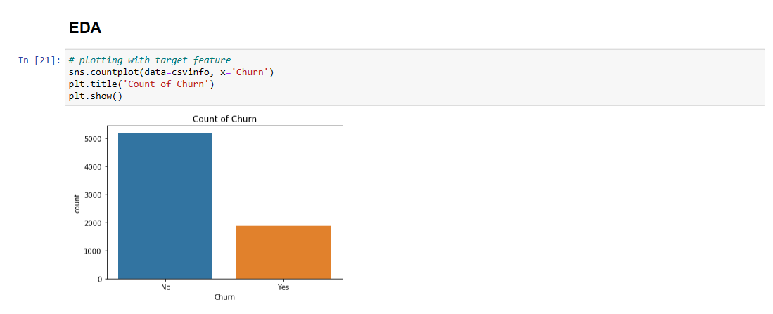
Data analysis part to show in depth analysis of each feature and its distribution in the dataset. From above graph total count of churn with yes and no values are compared. Graph shows total number of churn and non-churn users in the dataset which are 2000 and 5000
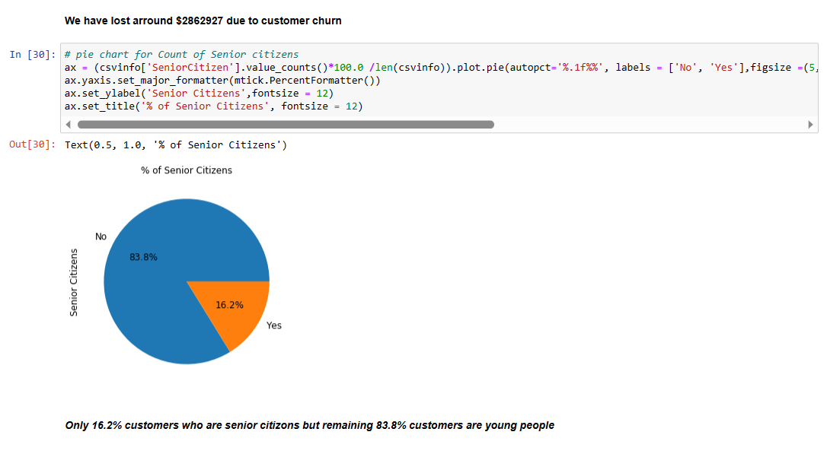
From above graph total number of churn customers based on age is calculated. Graph shows total number of churns customers who left company are mostly young customers which is 83.8 percent whereas only 16.2 percent are senior citizens

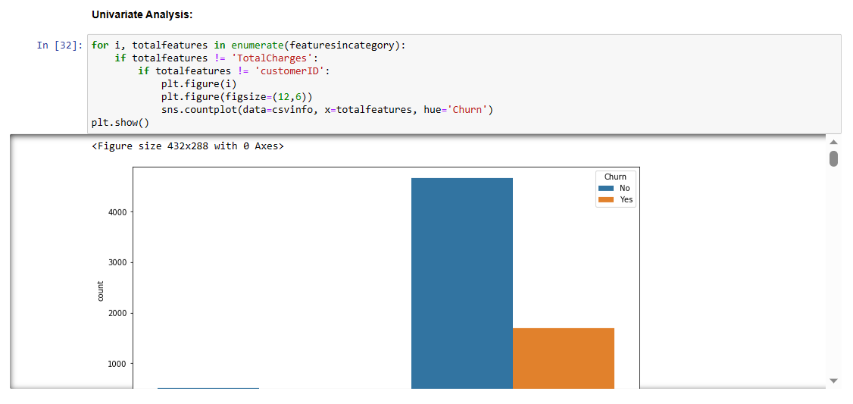
More data analysis is performed on various features compared with churn percentage which show which feature is important in churn prediction. Total features are extracted and using for loop and matplotlib multiple data analysis graphs are shown.
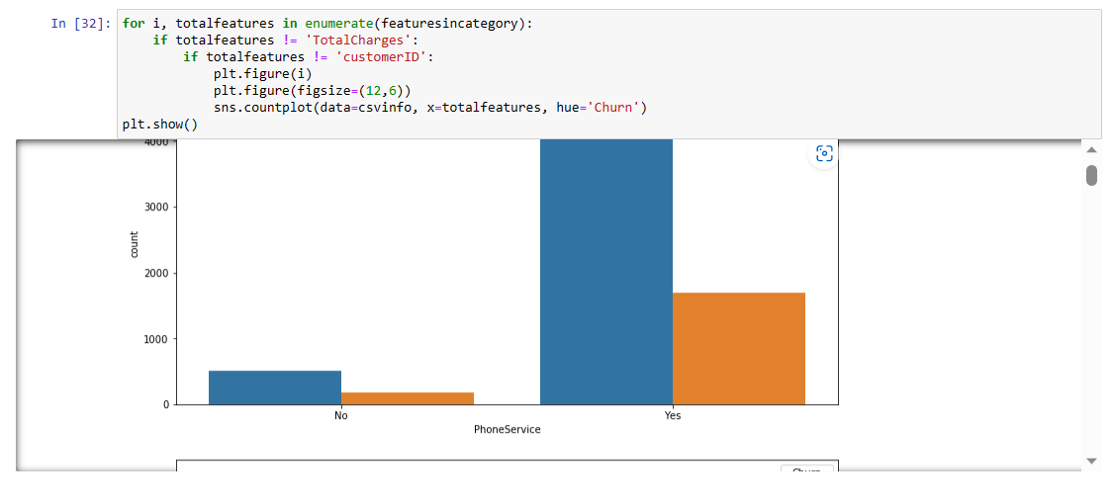
Graphical analysis for phone service feature with count of churn users with yes and no values. User who has taken phone services has more percentage of churn users compared to with out service users.
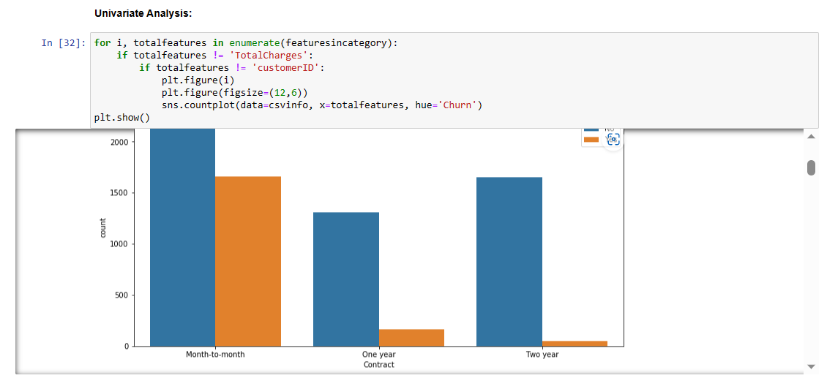
In this univariate analysis churn users who took contract for mobile services and their chances of leaving company is shown which shows customers with month to month subscription to network are most likely to leave network compare to one year and two year contract.
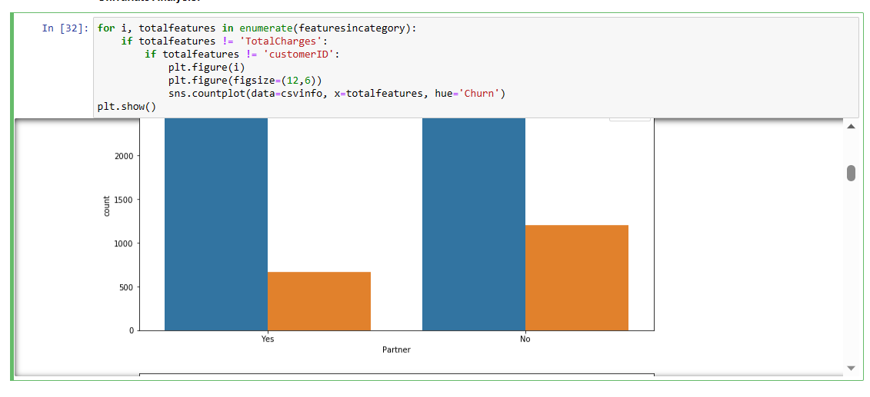
Partner features with churn analysis shows customer who has partner has less likely to leave network where are in other case who has no partner mostly likely to leave network
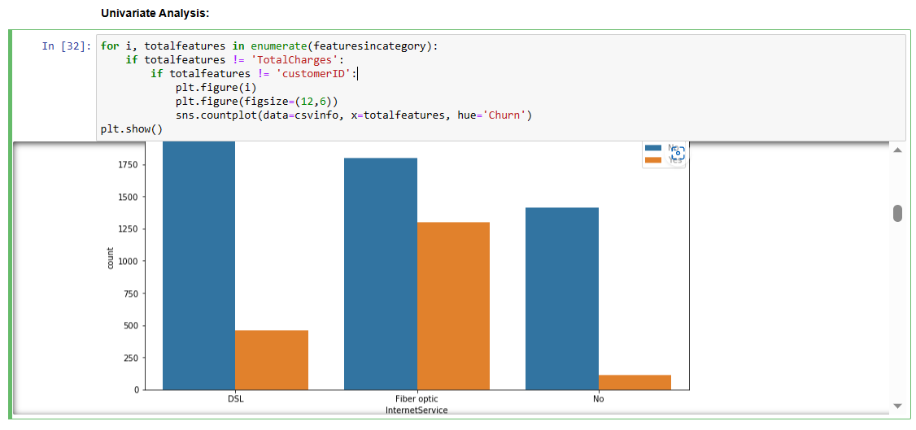
In this analysis DSL, fiber optic internet service feature is compared with churn label. From this graph customers how are subscribed to DSL, internet service is more likely to leave network
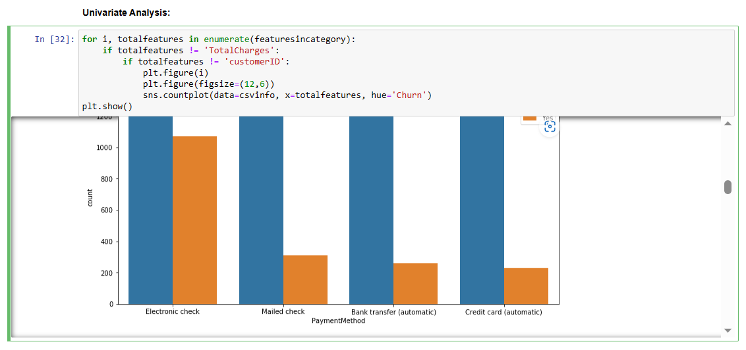
In this univariate analysis payment method is analysed with churn feature which shows mostly customers who pay form electronic check are more likely to be churn customers.
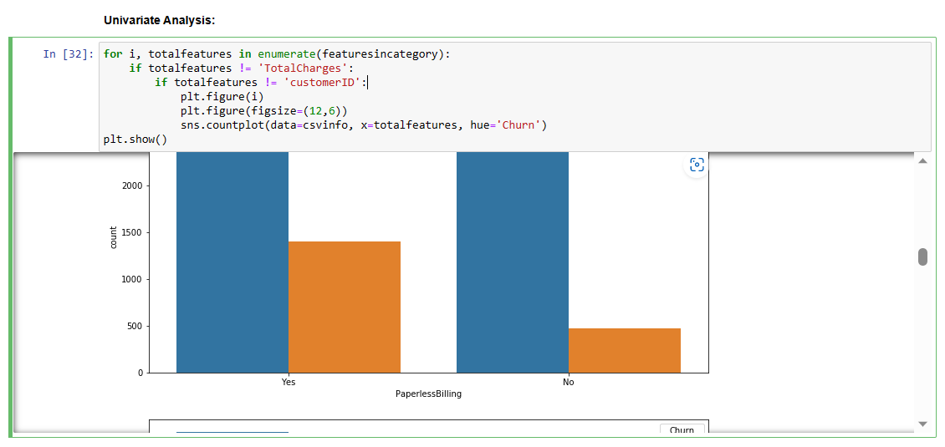
Paperless billing vs churn users graph shows customers who do payments in paper billing are most likely to be churn customers.
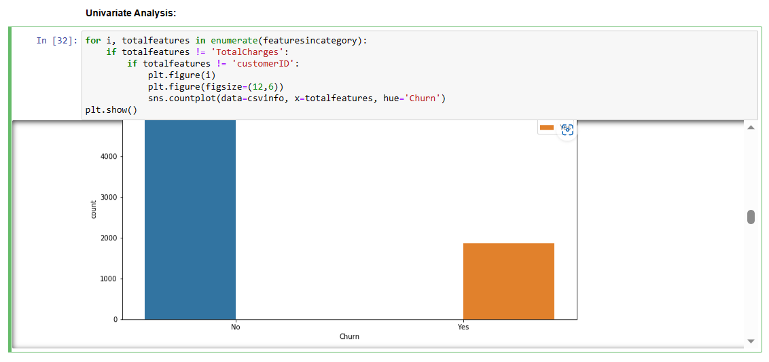
Data set shows lit of churn customers count with yes and No comparison. Analysis shows data set is not equally divided with churn and non churn users.
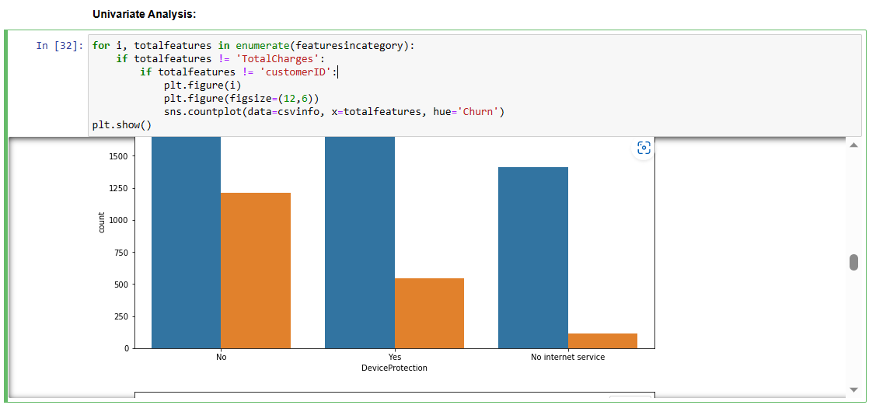
From this data analysis graph device protection vs churn users is calculated which shows customers who has not taken this service are most likely to be churn users.
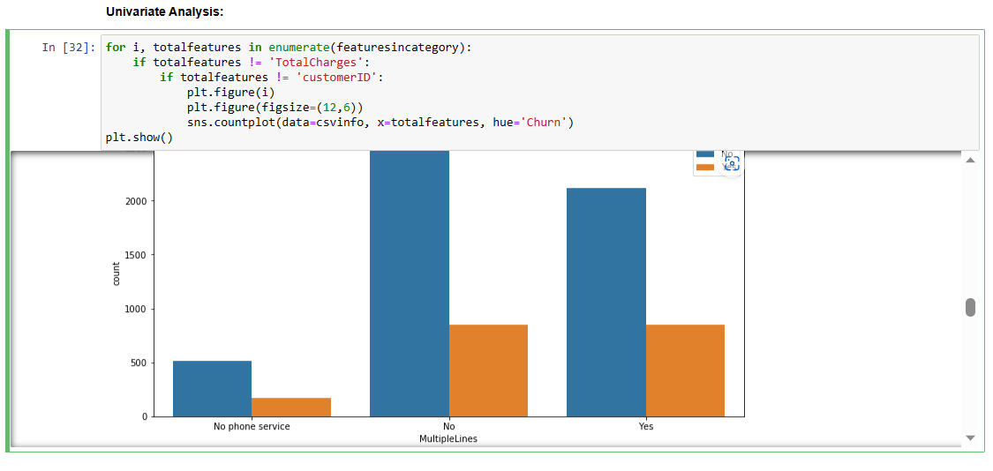
Multiple lines vs churn graph shows customers who has not taken multiple lines services and taken this service are equally distributed.
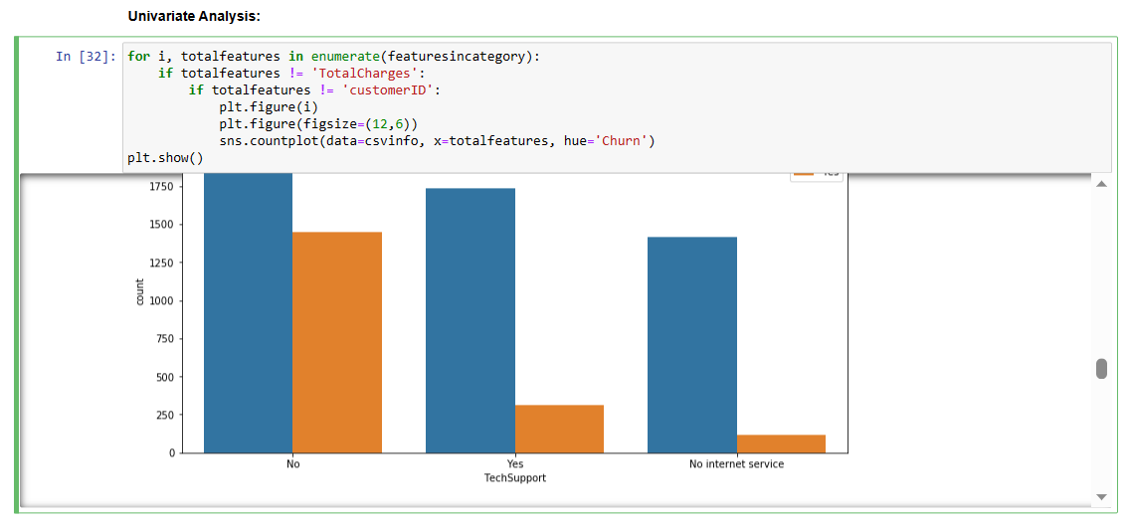
From this graphical analysis customers who has not taken tech support feature are most likely to be churn customers.
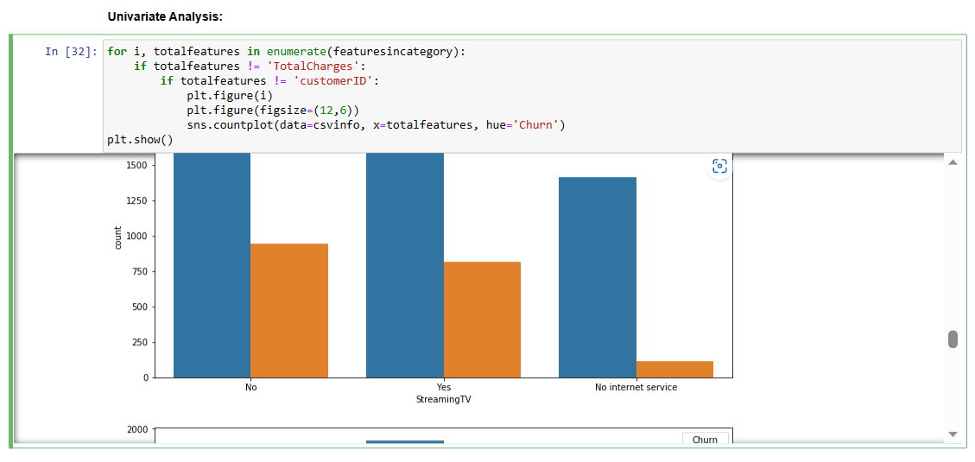
Customers who have taken steaming tv features are with out this feature are compared which shows customers with out this feature are most likely to be churn customers.
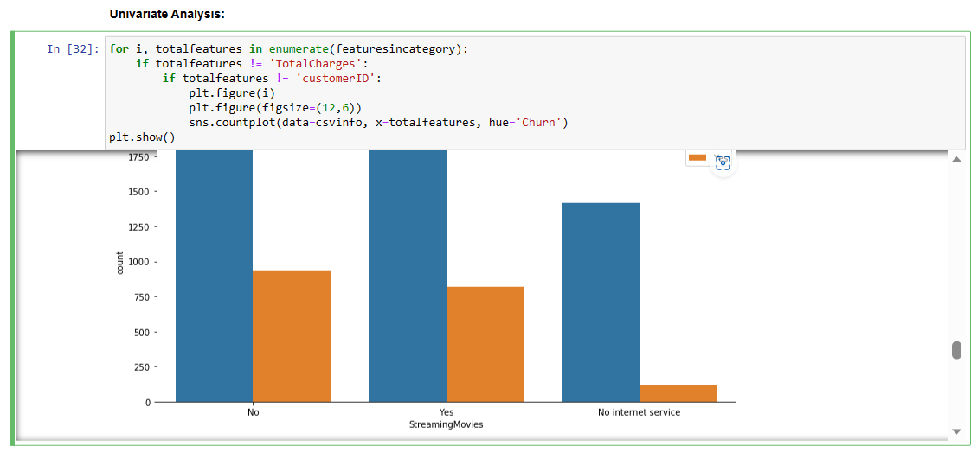
In this analysis customers has not taken steaming moves features are most likely to be churn customers.
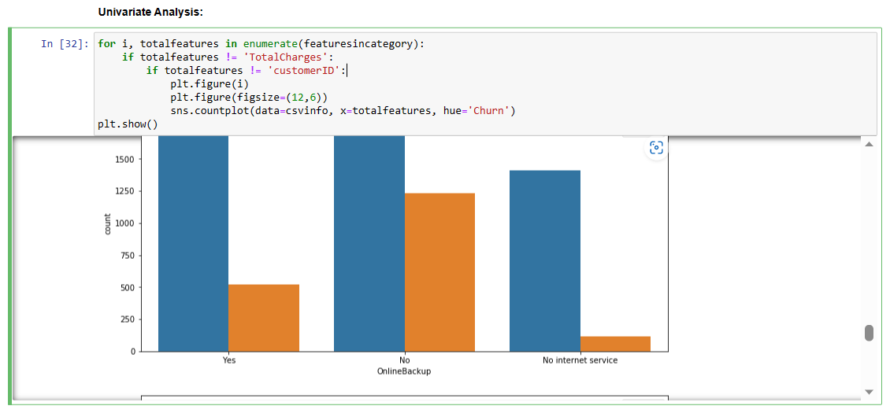
From this graph we can say customers who has not taken online backup has more chances of leaving network.

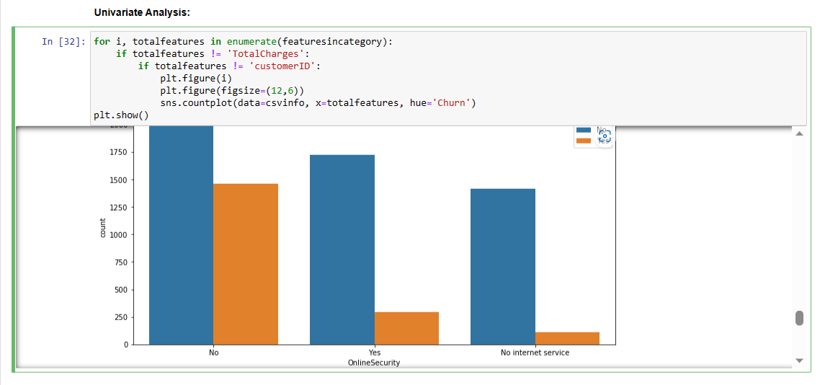
Graph shows customers who has not taken online security feature are most likely to leave network.
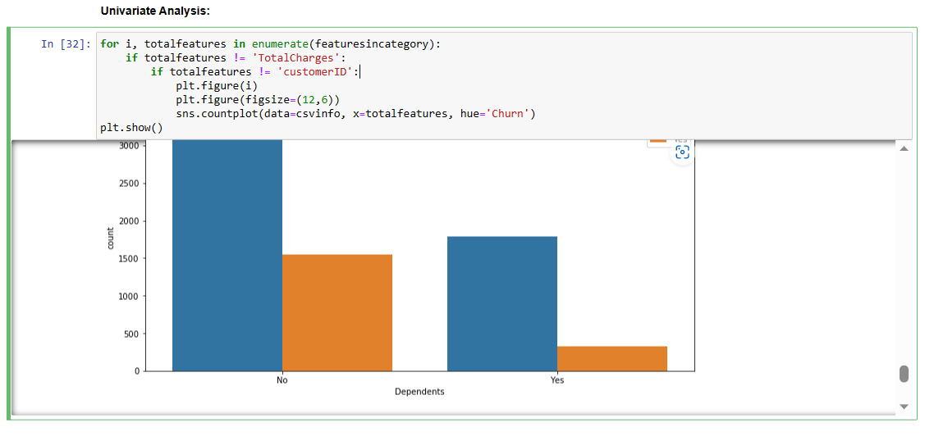
Graphical analysis shows customers who at not dependent are mostly likely to be churn customers.
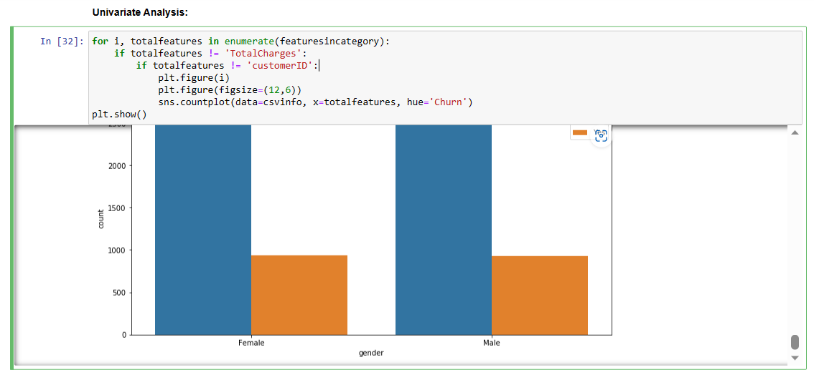
Graphical analysis shows equal distribution of male and female churn customers.

CONCLUSION
The purpose of this kind of study in the telecom industry is to aid businesses in increasing their profits. It is well known that one of the most significant revenue streams for telecom firms is churn prediction. The purpose of this study was to create a system that anticipates client attrition to be successful, prediction models must have high AUC values. The sampling data is split into 80% for training and 20% for validation in order to test or train the model. We picked to carry out for hyper - parameters adjustment and validation. To prepare the characteristics for machine learning algorithms, we used feature engineering, effective feature transformations, and selection methods. We also ran across the issue that the data was not balanced. Only 5% of the entries are customer turnover. This issue was resolved by under sampling or by utilising methods for trees that were not impacted by the issue. Due to their variety and suitability for this kind of predictions, four tree-based techniques were chosen. They include the algorithms Decision Tree, Random Forest, and GBM tree.
.

REFERENCES

1. Gerpott TJ, Rams W, Schindler A. Customer retention, loyalty, and satisfaction in the German mobile cellular telecommunications market. Telecommun Policy. 2001;25:249–69.
2. Wei CP, Chiu IT. Turning telecommunications call details to churn prediction: a data mining approach. Expert Syst Appl. 2002;23(2):103–12.
3. Qureshii SA, Rehman AS, Qamar AM, Kamal A, Rehman A. Telecommunication subscribers’ churn prediction model using machine learning. In: Eighth international conference on digital information management. 2013. p. 131–6.
4. Ascarza E, Iyengar R, Schleicher M. The perils of proactive churn prevention using plan recommendations: evidence from a feld experiment. J Market Res. 2016;53(1):46–60.
5. Bott. Predicting customer churn in telecom industry using multilayer preceptron neural networks: modeling and analysis. Igarss. 2014;11(1):1–5.
6. Umayaparvathi V, Iyakutti K. A survey on customer churn prediction in telecom industry: datasets, methods and metric. Int Res J Eng Technol. 2016;3(4):1065–70.
Yu W, Jutla DN, Sivakumar SC. A churn-strategy alignment model for managers in mobile telecom. In: Communication networks and services research conference, vol. 3. 2005. p. 48–53.
8. Burez D, den Poel V. Handling class imbalance in customer churn prediction. Expert Syst Appl. 2009;36(3):4626–36.
9. Zhan J, Guidibande V, Parsa SPK. Identifcation of top-k infuential communities in big networks. J Big Data. 2016;3(1):16. https://doi.org/10.1186/s40537-016-0050-7.
10. Barthelemy M. Betweenness centrality in large complex networks. Eur Phys J B. 2004;38(2):163–8. https://doi. org/10.1140/epjb/e2004-00111-4.
11. Elisabetta E, Meyerhenke H, Staudt CL. Approximating betweenness centrality in large evolving networks. CoRR. 2014. arxiv:1409.6241.
12. Brandusoiu I, Toderean G, Ha B. Methods for churn prediction in the prepaid mobile telecommunications industry. In: International conference on communications. 2016. p. 97–100

